Table of contents

- The Lufthansa on-board radios around 1930. , 11
- The on-board radio FuG10 17
- The FuG16 and FuG17 on-board radios 28
- Direction finder PeilG6 with direction finder r.ecei.vßr EZ6. 40
- The radio landing systems 45
- The "Hohentwiel" radar unit ( radio measuring device) 50
- The radar unit (radio measuring device)" Lichtenstein" 58
- H2S radar, Naxos and Berlin device 65
- The FuG25 a identification device 71
- The FuG101 a radio altimeter 74
- Appendix: Wehrmacht Tubes 77
- Literature ____________ . . . . . . . . . . . . . . . . . . . . . . . . . 78
- Register . . . . . . . . . . . . . . . . . . . . . . . . . . . . . . . . . . , 79

g

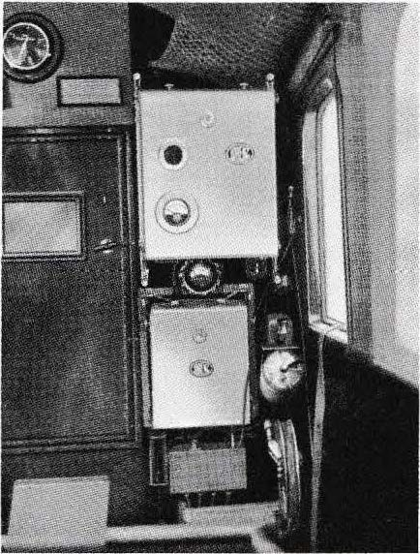1 The Lufthansa on-board radios at 1930

As early as 191 0, attempts were made to use radio technology, which was still quite new at the time, as a means of communication between aircraft and ground stations, and from 1916 to 1918, army aircraft were equipped with simple radios. However, aviation radio technology did not really take oft in Germany until 1925 with the preparations for the founding of Lufthansa. In that year, the Lorenz company was able to present and test a 100-watt on-board radio system (type SERF 008V25). lt operated in the long-wave range 220-55 0 kHz and could be used for telephony (A3, voice radio) as vvell as telegraphy A1 (soundless) and A2 (sounding). The receiver, designed for battery operation, consisted of an HF stage, an audion and two AF stages. The power supply for the transmitter was provided by a propeller generator mounted on the outside of the aircraft and driven by the airstream.

Figure 1.1 Lorenz V 25 on-board radio system from 1925, installed in a Jun kers G
24. Antenna power 100 watts, long wave.
Transmitter and antenna current meter on top, receiver below, Morse key and central operating switch to the right. Below t h e battery box, to the right of it the electric antenna reel for the 70-metre long trailing antenna.

11

In 1927 Telefunken also brought out an on-board radio system with similar power: 70 watts, 230-1000 kHz, type Spez.205 F. Shortly after that, Lorenz came out with the further development V 28 in 1928. Shortly afterwards, in 1928, Lorenz introduced the further development of the V 28 as the successor model to the V 25. The large "long-wave systems" from Lorenz and Telefunken were, with certain improvements, standard equipment on all long-range aircraft for many years, vvhich were also equipped with direction finding equipment from Telefunken.
After the good experiences that Lufthansa had had with radio equipment in large aircraft, it decided to equip the smaller aircraft (German and European routes) with radio as well. In 1929, Lorenz and Telefunken developed smaller and lighter devices for this purpose, the so-called small stations with an antenna power of 20 watts. These were then further improved as usual and in 1930/31, with the types SER FI 230 (Lorenz) and Spez.378 F (Telefunken), they reached a technical level that made larger series possible for the next few years. In the pictures 1.4 and
1.5 the typical construction of such on-board radio systems is recognisable. The equipment to be operated directly was located at the co-pilot's station in the cockpit, the other parts (transmitter, converter and anode battery) in the baggage compartment.
These small stations from Lorenz and Telefunken had the following technical features: The weight was reduced to approx . 25 kg, compared to approx . 50 kg for the 100-watt systems . A converter, fed from the 12 V on-board battery, was used to power the transmitter. The tvvo-stage transmitter operated on four frequenGies, v.vhich were switct\� remotely with a Bowden cable: 322 kHz
�cllre1f��.' (m e traffic), 344 kHz (reserve), 500 kHz (sea
wav,t c11J

l,J�.
- . �"' ../'
'\ C
_,�
'

�1'

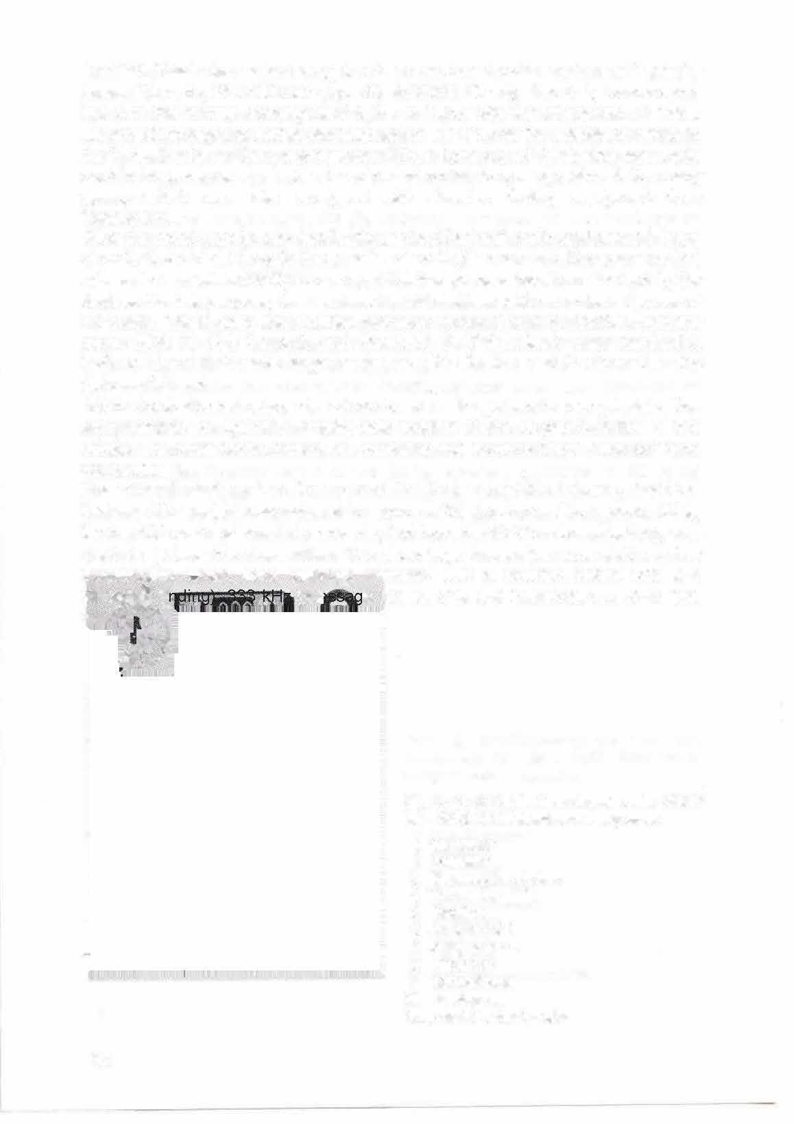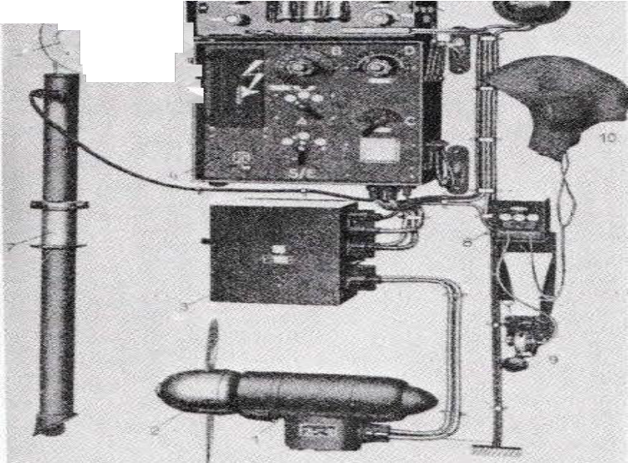

Figure 1. 2 Telefunk on-board radio 205 F from 1927. 70 Watt antenna, long wave.
- Generator
- Propeller
- Suppression chokes
- Transmitter
- Receiver
- Antenna reel
- Antenna shaft
- Morse key
- Microphone
- Hearing cap
Amp aerial current meter

12

Selilltr fmpftinger

NMM�/1 �� --� .------ ---

Centr11lor

Figure 1.3 Onboard radio 205 F (1927)

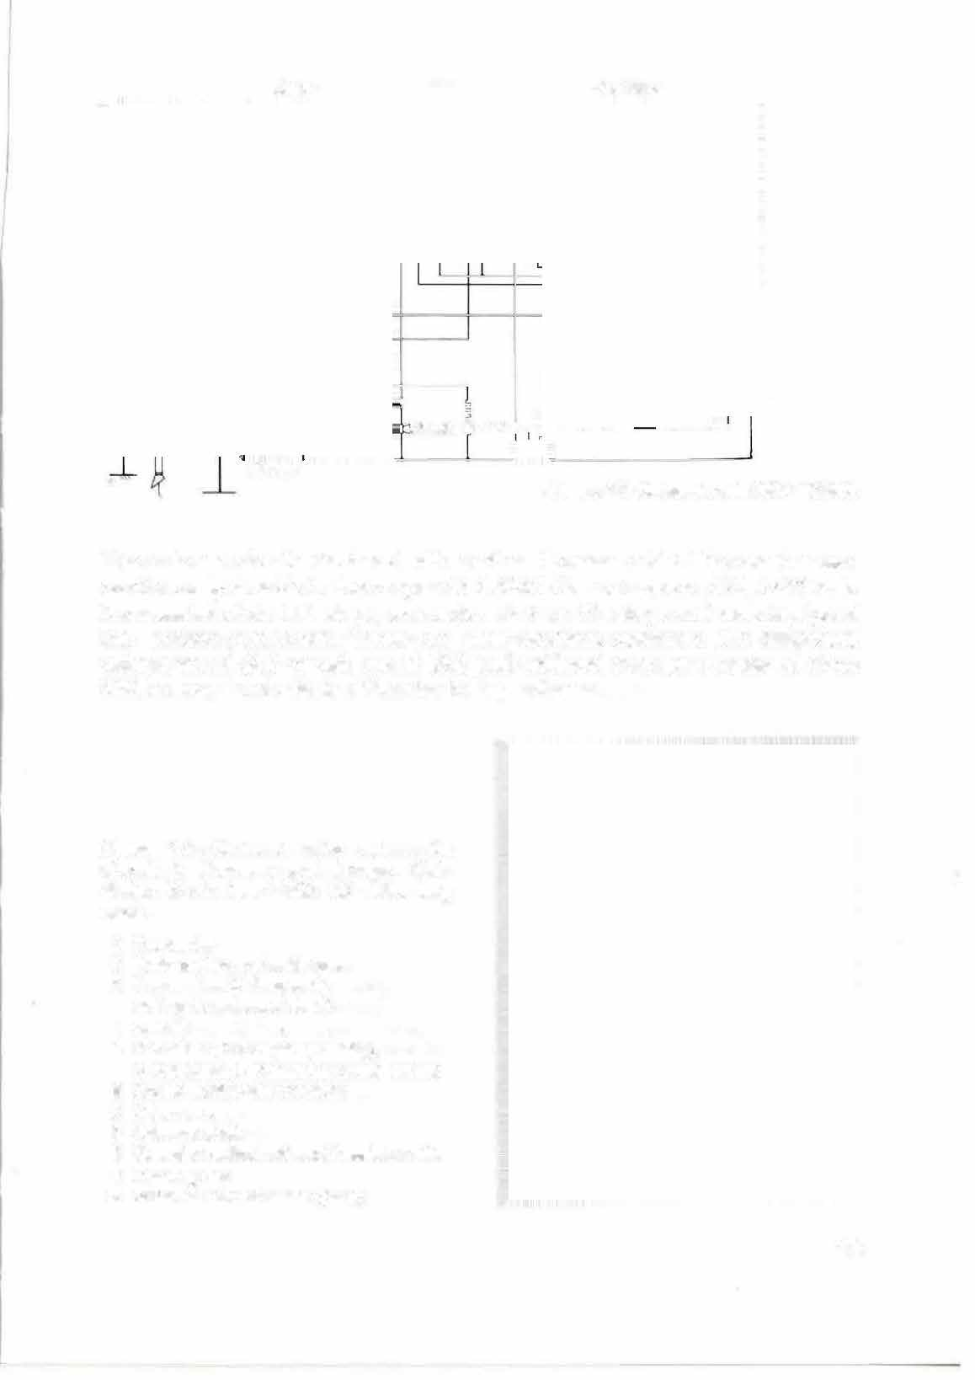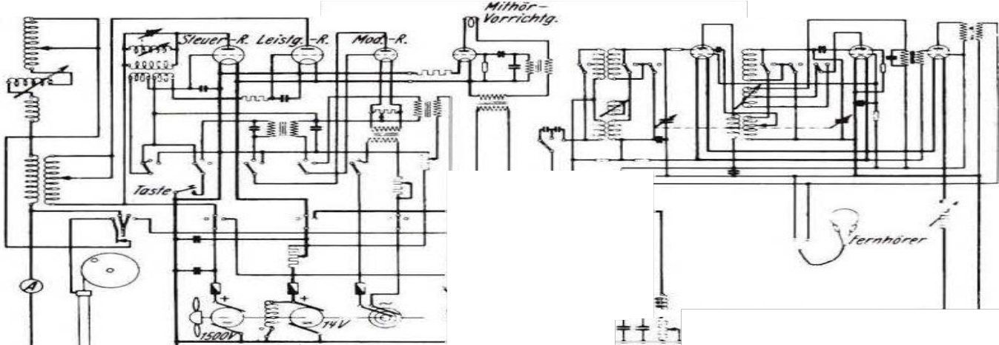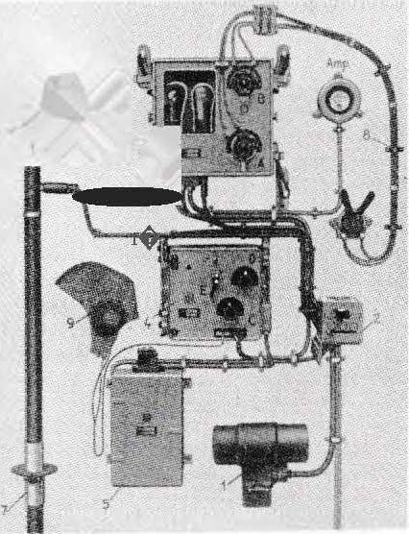

The antenna circuit was tuned with another Bowden cable. The receiver was continuously tunable in the ranges 31 5-350 kHz and approx. 470 -530 kHz. lt consisted of an HF stage, an audion and an AF stage and was equipped with screen grid tubes. These 20 -watt systems operated with telegraphy without sound (A1) or with sound (A2) and achieved average ranges of about 300 km over land with the 70-metre trailing antenna.

Figure 1.4 On-board radio system for aircraft in Germany and Europe. Klein station 378 F, from 1930, 20 watts, long wave.
- Converter
- Push-button and switchgear
- Transmitter (A frequency setting, B antenna circuit tuning)
- Receiver (C Frequency setting,
D Feedback, E Frequency range switch)
- Anode battery for receiver
- Antenna reel
- Antenna shaft
- Remote control unit and Bowden cables
- Hearing cap
- Antenna current meter (Amp)

13

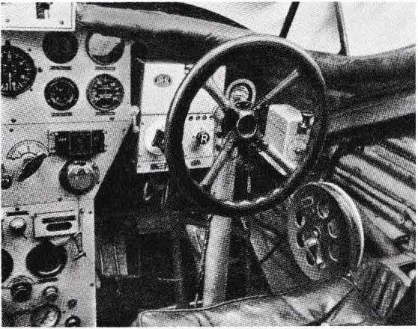Figure 1.5 Cockpit of a Jun kers aircraft from 1930 with Lorenz Kleinstation at the co­ pilot's seat.
Behind the "steering wheel": the receiver, the antenna current instrument and the switchgear with Morse key. The antenna reel is located on the side wall, as well as the Bowden cable control for transmitter frequency switching and antenna circuit tuning. The transmitter, converter and anode battery are located elsewhere.

After it had been possible to fly as far as America and East Asia, additional radios were required with which long-distance traffic over several thousand kilometres could be carried out Shortwaves, whose suitability for long-distance communications had been demonstrated a few years earlier by amateur radio operators, presented themselves for this purpose.
had been discovered. Lorenz and Telefunken built shortwave sets from 1928, which had a frequency range of 3 to 8 MHz (in some cases up to 11 MHz) and antenna power of up to 10 watts. In 1928/29, the largest aircraft of the time was built,
the Dornier Do X flying boat was equipped with the on-board radio system shown in Figure 1.7, which had a shortwave station in addition to the 100-watt longwave station.

Picture 1. 8 Junkers Ju 52. ►
First flight 1931 in Dessau. Used as a passenger aircraft by Deutsche Lufthansa and many other airlines; from 1935 also used by the Luftwaffe as a transport aircraft 1 "Tante Ju"). ,Atotal of 5000 examples were built. Length 18.90 m, wingspan 29.30 m. Three BMW 9-cylinder air­ cooled radial engines, each with a
500 kilowatts of power (670 horsepower). Range approx. 1300 kilometres. Continued to be built in France after 1945 as the AAC1, in Spain as the CASA 352 until 1952. The Ju 52 could still be found flying in the 1960s. At Düben airfield in Switzerland, it is still possible today (1983) to take sightseeing flights in a Ju 52 that served the air force there for 42 years.
1nitially the FuG 111, then the FuG 10 were used as on-board radios, as well as direction finder and radio landing system. The radios were arranged below the antenna mast at the passage to the cockpit. The fixed antenna of the FuG 10 (or FuG 111) was stretched from the mast to the fin; inside the mast was a rod antenna for the landing course receiver, which also served as an auxiliary antenna for the direction fin receiver. The approach receiver had a dipole antenna on the underside of the fuselage. The rotating bearing frame was located on the upper side of the fuselage in the wing area, visible in the photo behind the right engine. The towed aerial had its outlet on the underside of the fuselage.

14

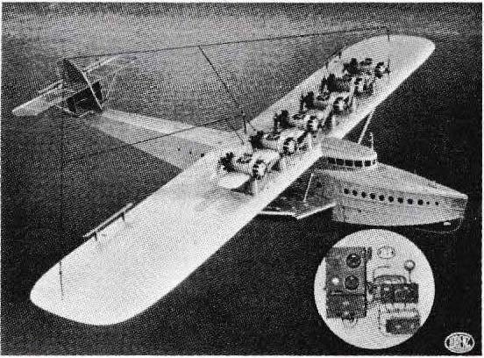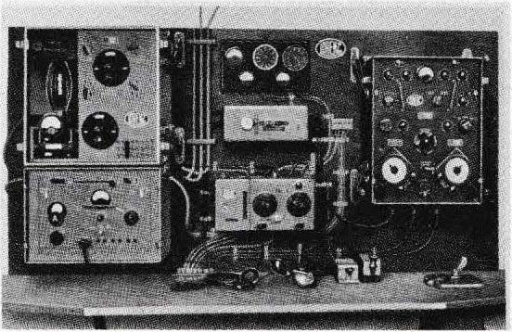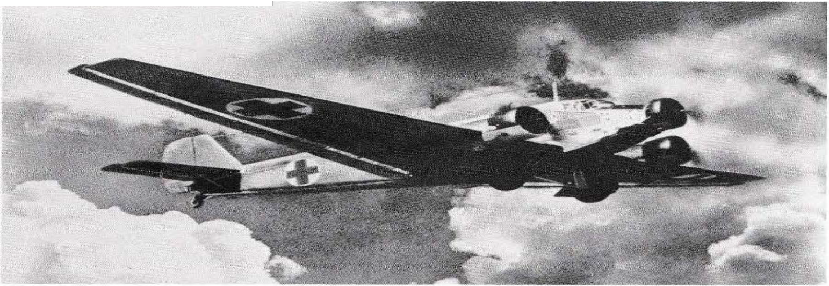

Fig. 1. 6 The Do X flying boat built by Dornier in Friedrichshafen in 1928/29,
' which at that time already
4

had room for 170 people. On the wing, the 12 drive motors in tandem arrangement. Wingspan 48 m, length 40
\
m. From 1930 onwards, long-haul flights to Africa - South America - North America.
l
\
Figure 1.7 On-board radio system of the flying boat Do X.
Top left: the 100 W long-wave transmitter, below: the receiver; in the middle: the control unit, on the right: the short-wave transmitter.
Wave station
(transmitting/receiving device).

15
\

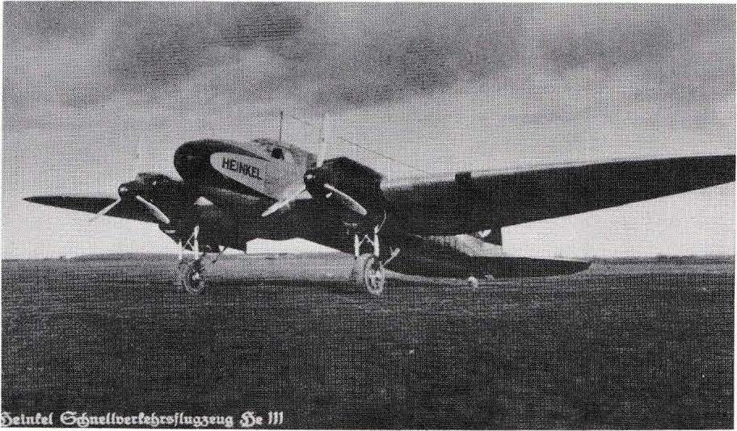

Picture 1. 9 Heinkel He 111.
First flight in 1935. Fast transport aircraft of Deutsche Lufthansa, taken over by the Luftwaffe as a fighter aircraft in 1937. A total of 6,000 were built. Length 16.50 m, wingspan 22.60 m. Two 12-cylinder Daimler-Benz engines, each 800 kilowatts (1100 hp), later Junkers engines up to 1000 kW (1350 hp). Crew of 4 or 5 men. In Spain, the He 111 continued to be built under the type designation C 2111 until 1956.
The radio equipment, FuG 10 with direction finder receiver and radio landing system, was located at the radio operator's position (between the antenna mast and the sliding roof). Fixed antenna from the mast to the rudder; on the underside of the fuselage the antenna of the landing system, the bearing frame and, from case to case, the antenna of the FuG 25a friend/foe identification device, as well as the trailing antenna of the FuG 10. Transmitter, receiver and antennas of the FuG 101a altimeter, which was common from 1942, were located on the underside of one wing.
For the aircraft mentioned in this book, the data refer to the large series with the highest level of development. The values given have been sensibly rounded.

The shortwave systems for long-range aircraft were constantly developed further in the following years. Among the top achievements were the Lorenz transoceanic stations, which were built from 1930 to 1941 in various designs according to the respective state of the art.

16

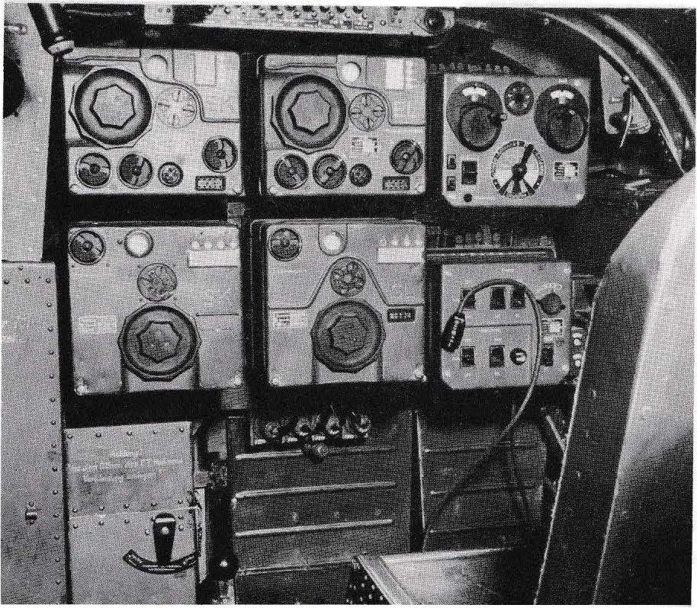2 The on-board radio FuG 10

Figure 2.1 On-board radio system FuG 10, installed in a Junkers Ju 88 (cf. Figure 7.10). In the upper row:
shortwave receiver E K, longwave receiver E L, remote control unit (FBG 13). In the lower row: shortwave transmitter S K, longwave transmitter SL, radio operator switch box and break coupling for the headset connection, to the right Morse key and remote control unit for the radio landing system's guide beam receiver. At the top of the picture you can see the circuit breakers with which the equipment was switched on and off.

17

The FuG 10 was the standard radio of the German Air Force and was installed in almost all multi-seat aircraft. lt was developed by Lorenz in 1937, went into series production in 1938, and by 1939/40 all aircraft in question at the time were equipped with this 70-watt on-board radio. , n total, 50,000 FuG 10 systems with about 300,000 units were built. The significance of this on-board radio system is thus considerably higher than that of its predecessors, of which only a few hundred were produced.
The task of the FuG 10 was to provide communication between the aircraft and the ground as weil as from board to board. The on-board radio system included a transmitter and receiver for each ofthe following areas:

Long wave 300 - 600 kHz ( FuG 10 L with transmitter SL and receiver EL). Main task: air traffic control. Average range about 500 km. Short wave 3.0 - 6.0 MHz (FuG 10 K with transmitter SK and receiver EK). Main task: communication board­ to-board and board-to-ground. Average range over 1000 km.

For long-haul aircraft, vvtlich until then had been equipped with the Lorenz transoceanic station, several hundred FuG 1Os with higher frequencies were buill from 194 1 onwards:
FuG 10 KI with 5.3- 10 MHz and FuG 10 K2 with 6.0- 12 MHz.
(FuG 10 K3 and K4 were development projects for the frequency ranges 6 - 18 MHz and 3- 9 MHz respectively).
The FuG 10's modes of oper�tion were long-wave telegraphy without sound (A 1), short-wave also A 1 or - with a built-in telephony add-on - also voice radio for ship-to-ship traffic (telephony, A3). Telegraphy could also be received on short wave (A2).

Tue on-board radio system included a fixed aerial (wire aerial stretched to the vertical stabiliser) and a trailing aerial, which was unwound from a remote-controlled aerial reel. Tue FuG 10 also contained the on-board intercom system for the aircrew, called Eigenverständigung EiV.

The receivers of the FuG 10

The FuG 10 had superheterodyne receivers (superhets) with the following structure: HF preamplifier, mixer stage, oscillator stage, 2 IF stages, demodulator, telegraphic superheterodyne, AF stage. The RV 12 P 2000 tube type was used uniformly in all stages, vvtlich brought considerable advantages for the maintenance of the radios and the maintenance of spare parts.

18

2 The on-board radio FuG 10

Figure 2.1 On-board radio system FuG 10, installed in a Junkers Ju 88 (cf. Figure 7.10). In the upper row:
shortwave receiver E K, longwave receiver E L, remote control unit (FBG 13). In the lower row: shortwave transmitter S K, longwave transmitter SL, radio operator switch box and break coupling for the headset connection, to the right Morse key and remote control unit for the radio landing system's guide beam receiver. At the top of the picture you can see the circuit breakers with which the equipment was switched on and off.

17

The FuG 10 was the standard radio of the German Air Force and was installed in almost all multi-seat aircraft. lt was developed by Lorenz in 1937, went into series production in 1938, and by 1939/40 all aircraft in question at the time were equipped with this 70-watt on-board radio. , n total, 50,000 FuG 10 systems with about 300,000 units were built. The significance of this on-board radio system is thus considerably higher than that of its predecessors, of which only a few hundred were produced.
The task of the FuG 10 was to provide communication between the aircraft and the ground as weil as from board to board. The on-board radio system included a transmitter and receiver for each ofthe following areas:

Long wave 300 - 600 kHz ( FuG 10 L with transmitter SL and receiver EL). Main task: air traffic control. Average range about 500 km. Short wave 3.0 - 6.0 MHz (FuG 10 K with transmitter SK and receiver EK). Main task: communication board­ to-board and board-to-ground. Average range over 1000 km.

For long-haul aircraft, vvtlich until then had been equipped with the Lorenz transoceanic station, several hundred FuG 1Os with higher frequencies were buill from 194 1 onwards:
FuG 10 KI with 5.3- 10 MHz and FuG 10 K2 with 6.0- 12 MHz.
(FuG 10 K3 and K4 were development projects for the frequency ranges 6 - 18 MHz and 3- 9 MHz respectively).
The FuG 10's modes of oper�tion were long-wave telegraphy without sound (A 1), short-wave also A 1 or - with a built-in telephony add-on - also voice radio for ship-to-ship traffic (telephony, A3). Telegraphy could also be received on short wave (A2).

Tue on-board radio system included a fixed aerial (wire aerial stretched to the vertical stabiliser) and a trailing aerial, which was unwound from a remote-controlled aerial reel. Tue FuG 10 also contained the on-board intercom system for the aircrew, called Eigenverständigung EiV.

The receivers of the FuG 10

The FuG 10 had superheterodyne receivers (superhets) with the following structure: HF preamplifier, mixer stage, oscillator stage, 2 IF stages, demodulator, telegraphic superheterodyne, AF stage. The RV 12 P 2000 tube type was used uniformly in all stages, vvtlich brought considerable advantages for the maintenance of the radios and the maintenance of spare parts.

18

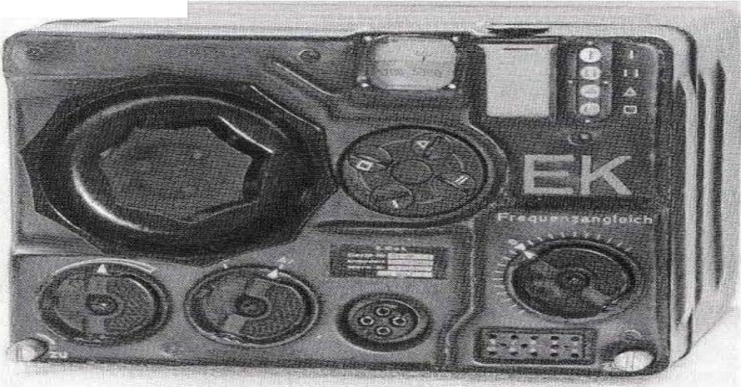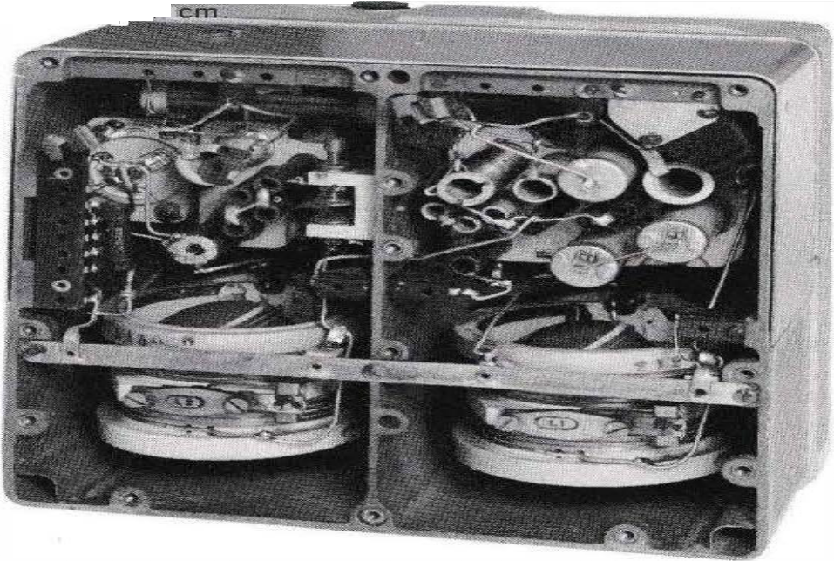1 2 3

Figure 2. 2
Receiver of the FuG 10
- Rotary knob for the free- quence setting (free- quence dialling)
- Frequency scale, below the circulany arranged 4 screws for adjusting 4
frequencies.
- Signs for the frequencies in use, a note field to the left of it
- Locking bolt
- Frequency alignment
- Connecting sockets for the plug of the tester
- Breakaway coupling
connection for. the headphone (for testing purposes)
- Changeover switch A1/A3
- Sensitivity adjuster 4 9 8 7 65 4
The transmitters had the following controls (cf. Figure 2.1): The !arge rotary knob for frequency setting at the bottom, the four locking screws above it and the scale at the top. At the top right, the symbols for the dick frequencies, below that the note field. At the top left, the rotary knob for frequency adjustment. In the middle on the right, the test instrument connection. The width of the transmitter and receiver wa? ,i.

Figure 2.3
Transmitter module of the FuG 10.
Below, the two height-fixed variometers in kera mic construction.
Above, the oscillating circuit con densators for static and dynamic frequency com pensation.
The tubes were arranged in a plug-in second module.

19

l
�· ';

CJ; t-<= ---,

wa w WIS w

VI : w w w
/ : 1 ß " 18 1 · 11

__: 1 _ -�1�j -'-"I _ ,!
t--0=>-i C19
+AEl_.....__��--•A;;;.EI_T_ _ .....;.:..�'":.

.
't.... -.• �!�. .,

wz

;.1e. Li

u1
1

Figure 2.4 Principle circuit of the receiver
The sequence of stages corresponds to what is still common today in high-quality AM broadcast receivers using transistor technology: H F stage, additive mixing stage, the oscillator drawn below, three Z F stages, demodulator diode, N F stage. Below is also shown: The control voltage di ode for generating the voltage for the automatic gain control, as well as the telegraphy superimposer for Al reception. Tube configuration: RV 12 P 2000 (W 43 is the sensitivity adjuster).
For receivers without automatic gain control, the diode stage with tube 10 and a Z F stage were omitted.

The receiver and transmitter of the FuG 10 had frequency-calibrated scales, whereas previously radio sets still had degree scales and frequency tables or calibration curves, with which setting the frequency was a cumbersome and lengthy procedure. Four operating frequencies could be set on the precision drive of
The receiver and transmitter must be locked in place: With the large rotary knob"

Frequency selection" (Fig. 2 .2) the desired frequency w° then one of the four detent screws was turned by 90
as set on the scale and with a poker or coin. lt

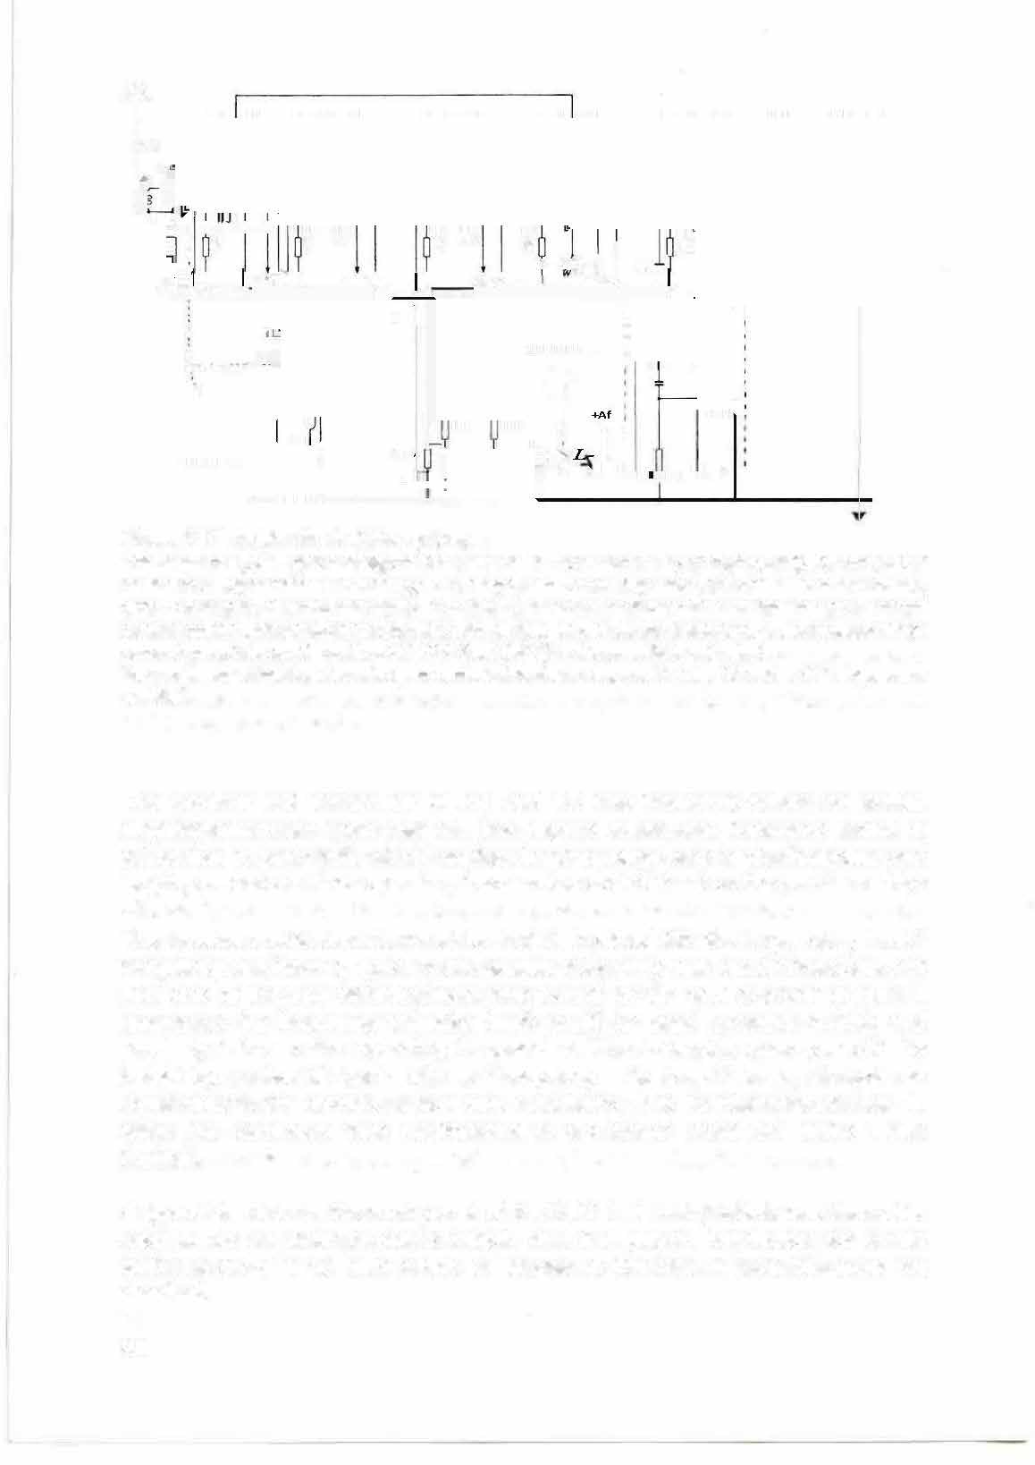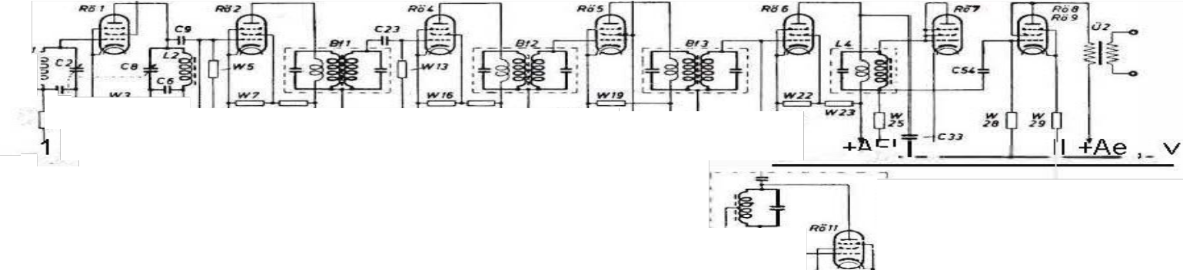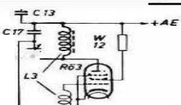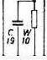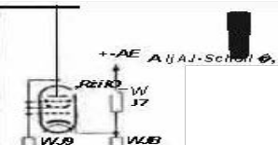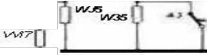necessary, the frequency selection knob could be used to switch quickly and precisely between the operating frequencies. The locked frequency could be varied by a few kiloher1z with a "frequency adjustment" knob, if such an adjustment to the remote station was necessary. lt is interesting that after 40 years this procedure was reintroduced in CB radios under the name "Delta Tuning".
A typical feature on the front panel of the FuG 1 0 units, which was then also adopted for all other on-board radios, was the plug-in connection for a test voltmeter. ( PV 1 0), with which all stages of the unit in question could be checked.
20

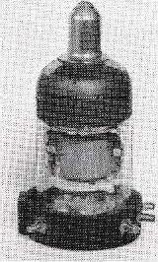Figure 2.5 The most widely used Wehrmacht tube RV 12 P 2000.
Height 4.5 cm, top the connection of the control electrode. Characteristic data: 1 nput resistance greater than 100 Mn, pentode with a slope of 1, 5 mAN, max. anode power loss 2 W, anode current up to 8 mA, usual control grid bias -2 V.
Electron tubes of this type were active components comparable in their effective action to the N-channel field-effect transistors of the choke type
{depletion type). The P 2000 was also used as a diode: Connections of anode {Al, control grid {G 11, shield grid { G 21 and brake grid {G 3) to each other.
connected.

and to which a quartz oscillator (PQK 10) was connected to check 1he calibration of the scale. The PV 10 had a rotary switch with which the most important measuring points of the radio were scanned, and the switch was dimensioned in such a way that the pointer always moved to the same setpoint when the measured values were correct. This meant that the maintenance staff could immediately see whether the relevant stage of the radio was in order without having to read, convert and compare scale values. This simple and quick test procedure was only remembered for television sets after 30 years: instead of laboriously "poking around" with a measuring device at various points of the complicated circuit, the service technician can now see from a yes/no indication whether the stage in question is in order. The pluggable modular design of the individual components introduced with the FuG 10 has meanwhile been adopted for television sets and in industrial electronics in order to make defective devices ready for operation again at the place of use by quickly replacing a component.

The FuG 10 transmitters

The transmitters (S 10 K and S 10 L) ......an antenna circuit power of 60 or 70 W for telephony (A 1) a nd 30 - 40 W for HF telephony. They had a two-stage design with an oscillator and a downstream HF amplifier. Both stages were equipped with RL 12 P35 power tubes, the amplifier stage with two parallel-connected tubes. Frequency setting and locking were the same as for the receiver. As tuning elements, the transmitter had height-fixed variometers, two coils connected in series on ceramic bodies, which were tvvisted against each other and thus changed their total inductance.
In contrast to the Allies, whose HF and UHF radios were almost exclusively designed for crystal control of the transmitter and receiver oscillators,

21

free-running oscillators were used in German units. One of the m ain problems in developing the equip ment was to ach ieve the necessary stability and frequency constancy of these oscillators in the wide tem perature range of -50 to -50°C.
+ 50 °e can be ens u red. The decision to use tu na b le units a nd free oscil lators was
a decisive factor in the electrical and mechanical desig n of the unit. The required frequency stability was achieved through rigid and ext remely stable construction of light metal injection m ou lding, even under shock and im pact stress.
The i nfl ue nce of temperature fl uctuations on the oscillato r frequency was reduced to a perm issi ble level by tem perature com pensation: Ceram ic capacitors with negative tem perature coefficients red uced these freq uency fluctuations in the receiver and transmitter to 1/10 of the deviations of an u ncompensated circuit. In addition to this static temperature compensation, a dyna m ic tem peratu re compensation was applied to the transmitter of the F uG 1 0 K, which also eliminated a frequency deviation occu rring during the keystrokes with the he Ip of compensation capacitors (frequency com pensation throug h the heat loss in the oscillation capacitors occurring during the keystroke). In the wide tem perature range from -50 to -40°C, the
+ 50 °e, the frequency deviation was less than 0.03 %, even with fluctuations of
22 to 29 V in the power supply system. The quality of the Morse code thus corresponded to that of a transmitterwith crystal control, even at low frequencies.
For beamless tu ni ng of the tra nsm itter oscillator to the frequency of the remote statio n, the rotary switch on the remote control u nit was set to "whistle in" (whistle in on the beat gapofthe own receiver).

51-uer,tuf-
I High fr-qu nz Vrstörk.trstufe I
T

01
,.,

A.nlMM

Figure 2.6
Principle circuit of the transmitter.
Variometer tuning. Control stage in capacitive three-point circuit. (C 12 is a neutralisation condenser).

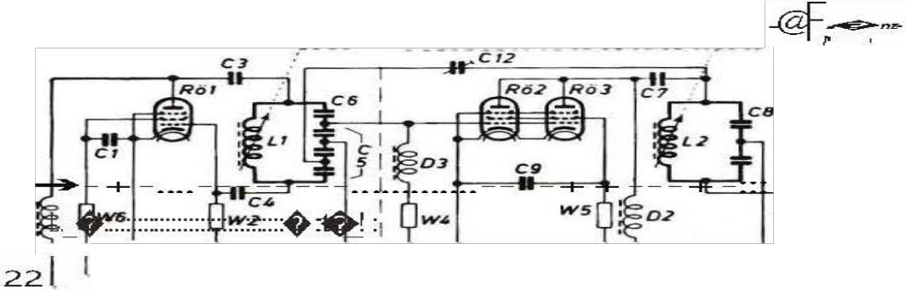
1 1

Remote control unit and control box
With the remote control u nit (F BG 3), the radio operator could select the equipment set for sho rt or long wave, as well as the tra iling or fixed antenna. Turning the switch (Fig. 2. 7) resulted in a choice:
- Short-wave operation with short trailing antenna (approx. 10 m)
- Long-wave operation with long trailing antenna (70 m)
- Ku rwave operation with fixed aerial
- Long wave operation with fixed antenna
For rem ote tuning of the antenna tuning devices near the antenna to the operating freq uency, rotary field transmitters for fixed or trailing antennas were insta lled. The m axi m um antenna current was indicated by a pointer i nstru ment.

Rotary switch with the
The "Trailing antenna and short-wave or long-wave operation" or "Fixed antenna and short-wave or long-wave operation" settings; the "Whistle-in" setting (without antenna) is at the bottom.
1
2 Push-button for pre-tuning the antenna with reduced transmission. Above this is the toggle switch for releasing or catching up the trailing antenna; to the left of this i s the corresponding indicator.
3 Crank knob and scale for tuning the trailing antenna.
4 also for fixed antenna.
5 Antenna current display.
3 S 4

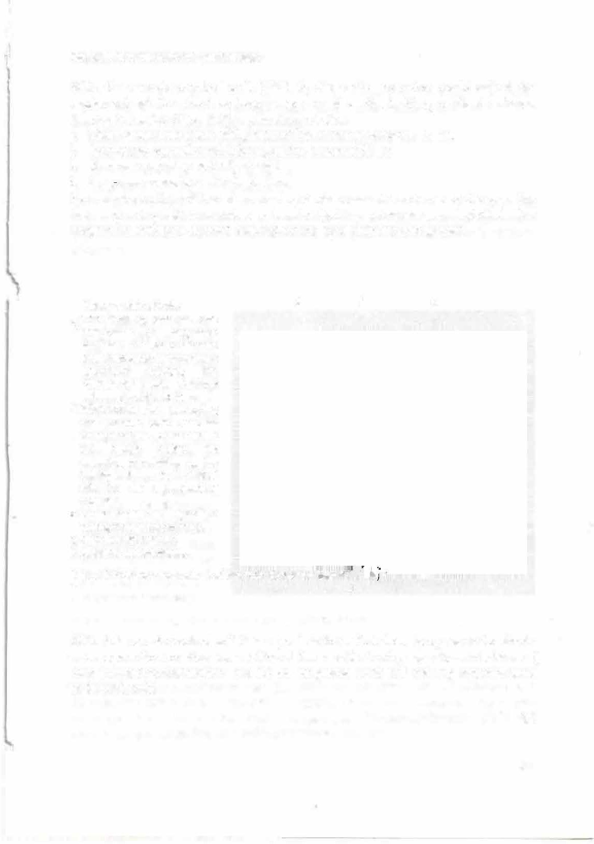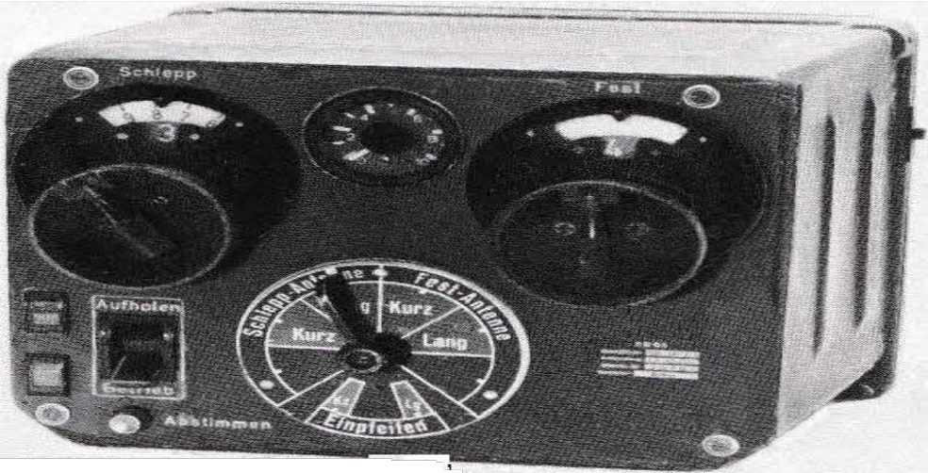Figure 2.7 Remote control unit of the FuG 10 system (width 22cm.
1

With this remote control unit it was possible to switch from long -wave to short­ wave operation or vice versa without the need for tu ning operations in between. ( For a planned special version FuG 10 KK, longwave units and trailing antenna were to be om itted).

23

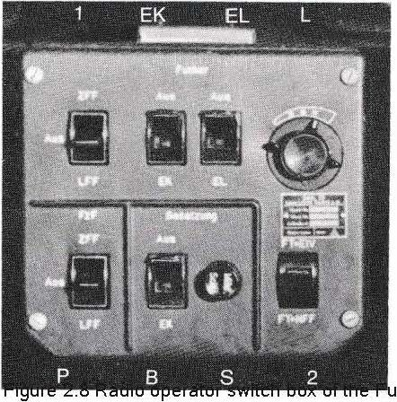The switch box (Figure 2.8), which was also operated by the radio o�rator, served to connect the crew members to the various on-board radios. lt was used to connect the output voltage of the FuG 1 0 receivers and the on-board intercom system (EiV) to the sockets for the headphones (pilot's head covers), as well as the output voltages of the other radios, e.g. direction finder, radio landing system and FuG 1 6.
Radio headset to homing receiver (Z FF 1 homing beacon) or radio landing
receiver (LFF landing beacon).
(Prerequisite: Switch 2 to FT. )
P Switching through the receiver from Z FF or L FF to the pilot.
E K Radio operator on shortwave receiver. E L Radio operator on long­ wave receiver.
2 With FT, the radio operator heard the selected receiver Z FF, L FF, EK or E
L. With FT+ EiV, the radio operator heard the on-board receiver Z FF.
and EC or EL.
L Volume of the on-board intercom (EiV) in three levels.
S Switch off the gunner's microphone if the crew is disturbed by the sound of gunfire.
B Crew headphones to shortwave receiver.
G10 system (width 20 cm).

Other special design features of the FuG 10

In the design, attention was paid to compact, space-saving construction and the lowest possible weight. The units were made up of plug-in modules that could be manufactured, tested and replaced independently of each other (see also Figure 3.2). The stable and rigid construction of light metal injection moulding was already mentioned in connection with the required frequency stability. For the protection of the personnel, the units had rounded ec kens as well as recessed and partly foldable operating elements.
1 n the aircraft, the equipment blocks of the FuG 10 were easy to replace: A quarter turn of two locking bolts was sufficient to unhook the unit from its holder. All electrical connections to the on-board wiring were made automatically by means of plug contacts (blade contacts) on the rear of the unit when it was hooked into the spring-loaded frame (see also Figure 3. 3).
24
\ 1 -

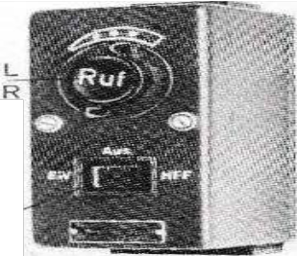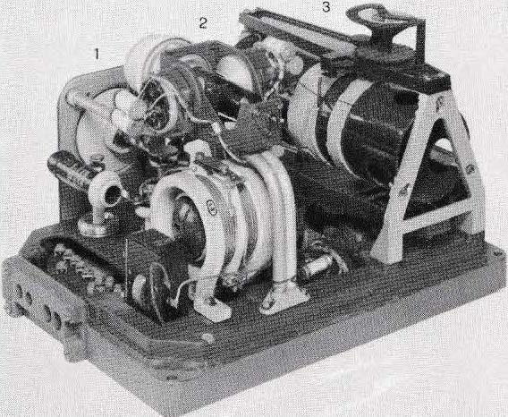The FuG 1 0, whose electrical and mechanical design also pointed the way for further on-board radios, was developed by an engineering group led by Dr. Hans RochCJvV, Hans-Rudolf Fischer and Helmut Wangerin. A team led by Dr. Hans Roch ow was responsible for the constructive design.
K. L. Vrany and Heinrich Zodtner; the overall technical management at Lorenz was Dir. Robert Herzog.

Figure 2.9 Headphone socket.
L Volume of the on-board intercom (Ei V).
- Call button to the radio operator (if he had switched off).
- The pilot could switch off from the intercom in the OFF or N F F position. In NFF he was connected to the homing receiver or the landing system, if the radio operator switched through accordingly. s The other crew members could switch their throat microphones on
and off with their switch S. The microphone was switched on and off by the radio.

Figure 2.10
Remote-controlled antenna tuning device of the FuG 1 0, for tuning the fixed antenna to the respective transmission frequency and for adjusting the receiver input c h an n e I to the fixed antenna. A similar device was available for the trailing antenna.
1 Antenna connection (in the circular ceramic insulator), below left a high-voltage capacitor. 2 Above, the vacuum relay for switching the antenna from the receiver to the transmitter. Below, the variometer for shortwave (coil windings on ceramic bodies, as on the transmit ter). 3 Variometer for long wave; on its upper side a scal e display for checking the synchronisation between the antenna tuner and the remote control. The base housed the rotating field system controlled by the remote control unit, which operated the two variometers and the necessary switches via a worm gear.

25


'.N 0)

Picture 2.1 1 Cockpit of a Ju 88 (A4) . see also Pi c ture 7. 1 0.

1 Elevator tr m wheel, 2 Rudder tr m wheel, 3 Rudder trim wheel, 4 Pump ove- sw tch box, 5 Quick release, 6 Pump over ind cator 7 Back trim button, 8 Vision holder box for head ights, beacons, unit light ng and pitottube heat ng 9 Mc ns sw tch
10 Course control switcil, 11 lgnit on sw tch, 12 L ght rod, 15 Starter sw tch, 16 Radiator f ap ad ustment 17 Propellers ad ustment 1 8 ta lp ane de-ic ng, 19 throttl e, 20 speed ad uster 21 lever brake, 22 nine-lamp device, 22 tr m knob,
24 Camber sw tch, 25 Landing gear control, 26 F ap and elevator ad ustment 27 Smoke control box, 28 AFN 2 indicator for bearing, homing and approach 29 A timeter, 30 Coupling for lighting, 31 A rspeed indicator 32 Coarseifine alt meter, 33 Fuel consumption indicator with switch, 34 lndicator for pitot tube heat ng, 35 Va ometer, 36 Rate ofturn
37 Course pointer 38 Revi holder 39 Artific a hor zon, 40 ETC detachment 41 Operating data table and deviat on tab e
42 Remote heading gyro for heading control, 43 Operat ona data table 44 Course control indicator, 45 Compass slave for headi,g control, 46 MG detent 47 Boost pressure gauge for engine L 48 for engine R, 49 Rev counter L 50 Rev counter R 51 Lubr cant pressure and fuel pressure, 52 Pressurised water warning, 53 Coolant temperature for engine L 54 fo- engine R, 55 Radio bear ng indicator w th slave compass, 56 Belt guide, 58 Cartr dge guide, 59 Shell conta ner 60 Machine gun lashing, 61 Cable ductfor radio system, 64 Sauer
fuel pressure gauge for pilot 65 for observer 66 fuel and lubr cant supply, 67 selector sw tch for 66, 68 fuel supply, 69 outside temperature,
70 1iqht control panel, 71 hose for observer s breathinq apparatus, 72 rem ote contro unit for frequency retuninq of FuG 1 6 receiver ( frequency a ignment) , 73 FuG 16 socket for 1he observer (vo ume control and change-over sw tch), 74 Folding crank 76 Cab e duct 77 Camera holder 78 Tool bag, 79 Contro un t for the FuG 25a friend/foe recogn t on dev ce (change-over switch for key identf cation 1 or 2, test l:utton and signa lamp). 2, test button and signa lamp), 80 Cartr dges, 81 Remote control unit for bearing and homing 82 Switch for single engine flight 83 111 uminati on of instrum ent panels, 84 Selector sw tch, 85 lgnition switch box, 86 N ozzle of heati ng system, 87 Emer;iency release for course control, 88 Knee cushion, 89 Seat ad ustment 90 Emergency throw lever 91 He
bei for LM, 92 Own speed sensor 93 Attude compensated a rspeed indicator 94 A ming device, 95 D rect on sensor, 96 Rare gun, 97 Camera holder 98 Row caster, 99 A titude c::,rrection transducer 100 W nd speed transducer 101 Compass supportswitch,
102 footrest 103 rudder foot lever with impeller brake, 104 control column, 105 on-board � ock 106 sw tch button for on-board communication (Ei V), 107 Course setter, 108 Throw button, 110 Kuvi holder, 111 Heated w ndscreen, 113 Room light, 114 Pilot seat, 115 Seat adjustment, 116 UV light, 117 Head canopy connect on cable for observer.

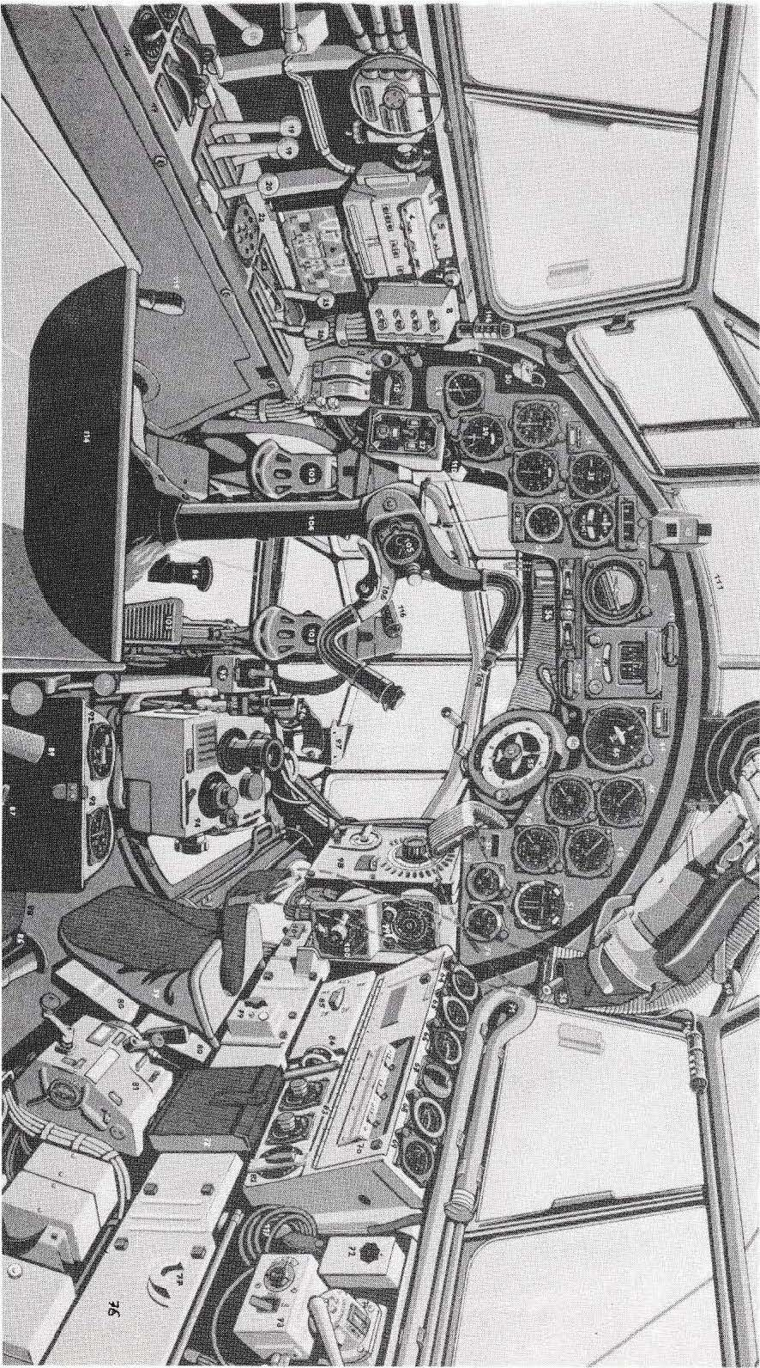

1

3 The on-board radios FuG 16 and FuG 17

The FuG 16 was the German Air Force's standard \/HF radio. lt was used for ship-to-ship communications as well as for
\
between aircraft and ground stations at distances of up to about 300 km. The frequency range ofthe FuG 16 was 38.� - 4-� .3 MHz, the FuG 17 of lhe same design had a range of 42.15-47.75 MHz. Developmenl began in 19 36/37, and in 19 39 the first FuG 1 7s were used in close reconnaissance aircraft.
An extraordinarily !arge number of these radios were produced: 1800 Fu G 1 7s and around 15 0 000 Fu G 16s. From 1941, the Fu G 16 was installed in almest all aircraft equipped with the Fu G 10, and then from 1942 onwards, the Fu G 16 was used in all aircraft equipped with the Fu G 10.
as FuG 16 Z and, from 1 943, as FuG 16 ZY in all day and night fighters that used the
to combat incoming bomber units. These radios were developed at Lorenz by an engineering group under the leadership of Dr Walter KI oepfer; Heinrich Zodtner and Wil li Gurk were responsible for the design.

FuG 16 and 17 worked with amplitude mod.Jlation for voice radio (telephony, A 3), FuG 17 could also be switched to telegraphy (A2) . The transmission power was approx. 10 watts. Since the range of UHF is limited by the curvature of the earth, the following values were obtained for radio communication with ground stations: Fliqht �in m1 00 1 000 1 0 000
Range in km 40 1 00 300
These ranges were - apart from special long-range aircraft - carl)letely adequate and also had the advantage that at greater distances radio traffic could
neither be intercepted nor disturbed by the enemy. The aerial used was generally a wire aerial stretched to the rudder
1 n contrast to the Fu G 1 0, the receiver, transmitter and control unit ofthe FuG 16 were combined into one unit (Figure 3.1; width 37 cm). For maintenance purposes, however, they could easily be separated from each other and disassembled into further components (Figure 3.2). As in the case of the Fu G 1 0, stable light meta! casting, modular construction and plug-in connection technology were characteristic features. The
28

1.

Receiver 4
"( Operating
8 Transmitter 12

1

3
9

2

7 6 5 15 14

Figure 3.1 U KW on-board radio FuG 16 (FuG 17) Receiver: 1 frequency scale, 2 frequency setting,
3 Four frequency detents, 4 symbols for the d e e n
5 Bottom sensitivity adjuster "Level", above frequency adjustment (in its zero position the trimmer for the scale adjustment is accessible under the rotary knob), 6 Test instrument connection, 7 Locking bolt.
Transmitter: 8 Frequency scale, top left the trimmer for scale calibration, 9 Frequency setting, 10 Four frequency detents, 1 1 detent indicator, next to it note field, 12 Vent, 13 Test instrument connection.
Control unit: 14 Transmit button "Telephony" for checking and tuning. On the FuG 16 ZY, the phase setting was at this point, with a fuse and a reserve fuse above it. The FuG 17 had a toggle switch here for on-board intercom/radio communication/navigation reception. 1 5 Mounting plate for screwing on the remote drive for frequency adjustment 5. Antenna current display at the top.
13 7

s

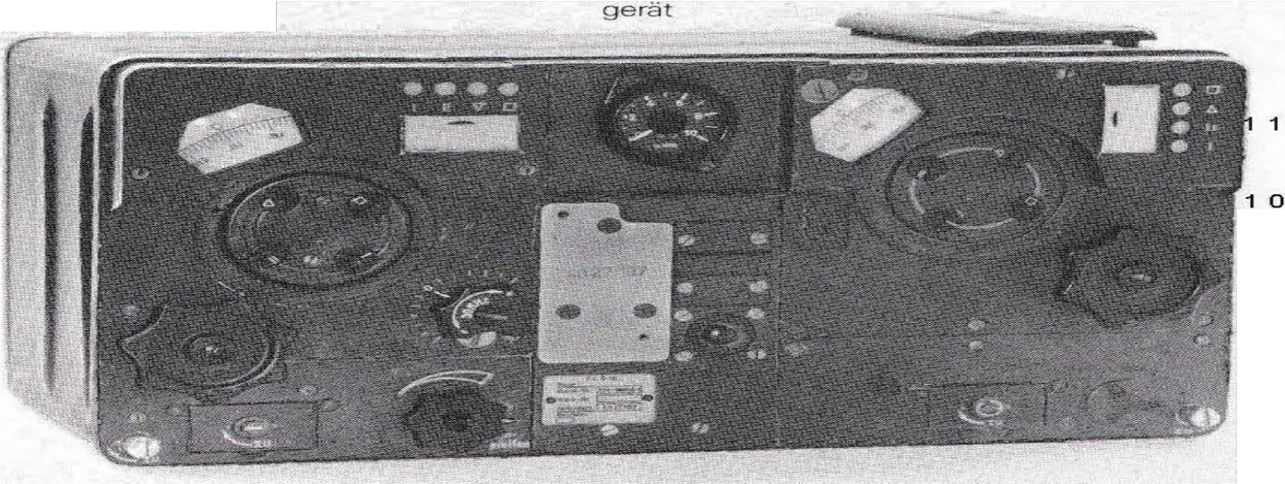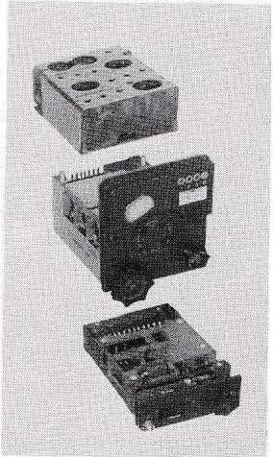

Figure 3.2 Plug-in modules of the FuG 16 receiver
In the middle H F part, above IF part, below N F part.

29

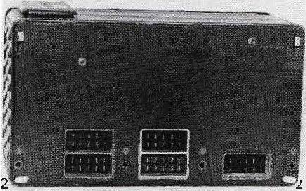The frequency was set on the frequency-calibrated scales of the transmitter and receiver. In addition, four frequencies could be preset and locked in the way known from the FuG 10, so that a quick and exact change of the operating frequencies was possible.
The receiver of the FuG 16 was a superhet with HF preamplifier, oscillator, mixing stage, three IF stages (3.1 MHz), demodulator, N F stage and a stage for gain control. As with the FuG 10, all tubes were of the RV 12 P 2000 type. The locked receiving frequency could be varied by ± 30 kHz by means of a rotary knob "frequency adjustment'', if such an adjustment to the transmitting frequency of the remote station was required. A quartz oscillator (PQK 16) was used to control the scale calibration, which could be plugged into a socket connector just like the test voltmeter mentioned for the FuG 10.

Fig. 3.3 Ba:i<of the FuG 1 6 .
1 Suspension bars, 2 locking bolts. Also visible are the blade contact strips for connection to the suspension frame and thus to the on-board wiring.

The transmitter of the FuG 16 was equipped with two RL 12 P 35 tubes. The first worked as an oscillator and frequency doubler, the second as a dowr.istream HF amplifier with grid voltage modulation. lts output power was fed to the antenna via a broadband, permanently tuned matching device; the antenna power of approx. 10 W could be reduced to 0. 1 W for short-range on-board/on-board traffic by means of a far/near switch.
A trimmer in the upper left corner of the transmitter was used to recalibrate the scale when changing the oscillator tube. To do this, the oscillator frequency was compared with the quartz oscillator (PQK 16) that could be plugged into the receiver To do this, the level adjustment knob of the receiver had to be turned to the right stop (position
The transmitter was the n put into operation without an antenna.
FuG 16 and FuG 17 we re characterised by a very high frequency stability for the time, which, as with FuG 10, was achieved by rigid injection moulding and temperature compensation with ceramic capacitors.
30

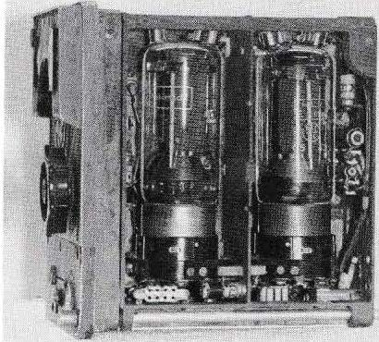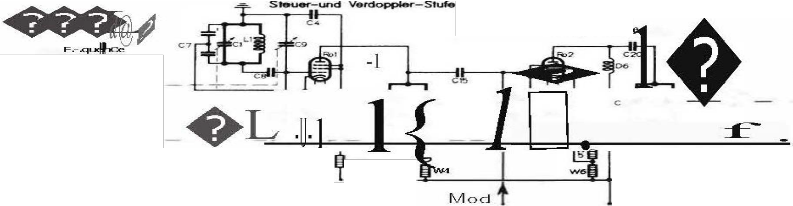

Figure 3.4 FuG 16 or FuG 17 transmitter with the two tubes R L 12 P 35.
}
\
The transm itter resonant circuits a re located in the cham bers below the tu bes.

1

Hfamplifiersu

..,..
\
W2

+

Figure 3. 5 Principle switching of the transmitter of FuG 16 and FuG 1 7.
Oscillator in three-phase circuit with ground, cathode and grid of the first tube. Frequency doubled in the anode circuit. Second tube is H F amplifier with grid volt:lge modula tion.

On the so-called control unit, which formed the central part of the unit block, there was a "telephony" transmit button for tuning and testing purposes. A second transmit button was located in the pilot's grip area. Both buttons switched off the receiver, switched on the modulation amplifier and transmitter, and switched the antenna from the receiver to the transmitter. 1 n the inside of the control unit was the modulation amplifier, on the FuG 17 besides that the tone generator for A2 te Ieg ra phy.

31

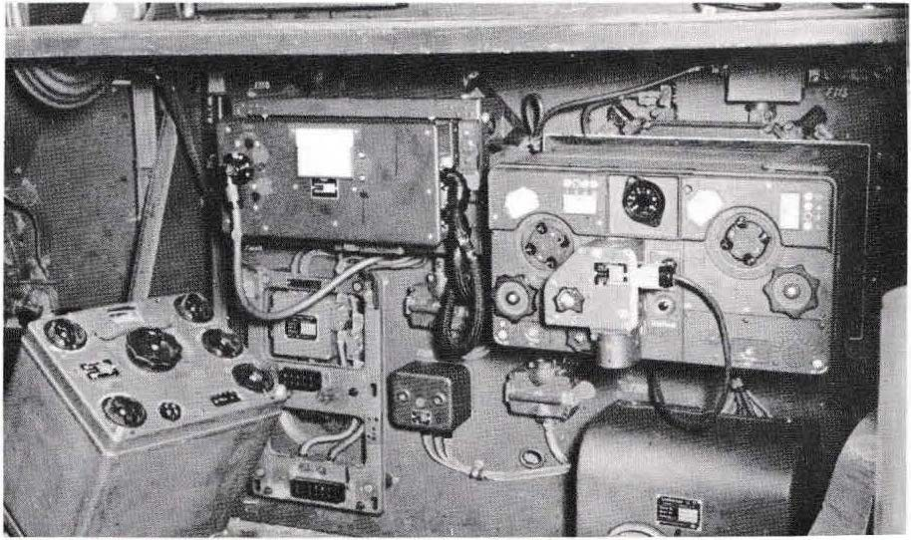

Figure 3.6 Right: FuG 16 with remote drive for frequency alignment of the receiver. Top centre: EBI 2 single-flight receiver of the radio landing system (on the left of the receiver the antenna connection with antenna cable is visible, next to it the adjusters for tuning to 38 MHz and feedback). Bottom left: Direction finder receiver EZ 6. Arrangement of the equipment under the work table of the radio operator in a Ju 290 long-range reconnaissance aircraft (cf. Figure 5.8 and 6. 14).

Remote controls: lf the FuG 16 vvas installed in such a vvay that it could not be operated directly during flight, the rotary knob "Frequency Angle I" mentioned on the receiver was operated with a remote control unit ( F BG 1 6 ). The FuG 16 was fitted with the servomotor shown in Fig. 3. 6 (remote control FA 1 6).
lf it was necessary to switch betvveen locked operating frequencies during flight, remote drives were also used to tune the transmitter and receiver (Figure 3.7). The frequency selector switch shm,vn in Figure 3.9c was then located at the pilot's or radio operator's position for remote control.
Before the FuG 1 6 or FuG 1 7 became available in 1939, the FuG VI I was used for single-motored aircraft.
short-wave range (2.so - 3. 75 MHz). The frequency setting of the transmitter and rece.Iver was carn. ed out on 1so0 scales
32

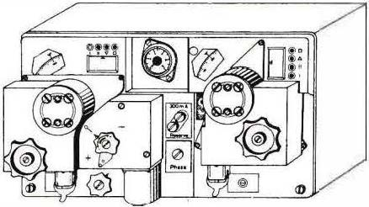1

Figure 3.7
FuG 16 ZY with remote drives for receiver frequency (left) , frequency alignment (centre) , transmitter frequency (right)

The on-board radio FuG 16 Z ( FuG 17 Z)

This aircraft radio was a version of the FuG 16 developed at the beginning of 194 2 which, with additional equipment, enabled instrument homi ng to the received transmitter. Additional devices were the fixed homing beam (P R 16), a homing prefix (ZVG 16) and a homing indicator (AFN 2). Compared to the FuG 16, the FuG 16 Z differed externally by t""° anti-piracy devices in the middle of the front panel (above the transmit button) as well as an additional antenna ronnectbn atthe rear, which served to connect to the homing device.
The antenna voltage of the target flying frame was keyed by the attachment at approx. 28 Hz and given to the receiver input of the FuG 16 Z together vVith an auxiliary antenna voltage. From the output voltage of the receiver, the attachment generated the DC value for the target flight instrument vVith the help of a phase comparison bridge (Fig. 4. 5). lt the aircraft's longitudinal axis pointed exactly to the received UHF transmitter, the vertical pointer of the instrument remained at its zero mark; if the flight direction deviated, the pointer deflected to the left or right, and the pilot saw that he had to correct the course accordingly. The second pointer of the instrument gave a directional value for the input voltage and thus also for the approximate distance to the transmitter. A homing switch was used to switch the FuG 16 Z from radio direction finding to homing and at the same time to switch the display instrument from the radio landing system or the direction finder to the FuG 16 Z system.
The FuG 16 ZS variant had a frequency range of 40.3 - 44.7 MHz and could therefore be used with both FuG 16 and FuG 17 devices. Under the designation FuG 16 ZE, a test series was run at the end of 1942 for range finding by an appropriately equipped ground station; target flying was not possible, however. These devices were replaced after a few months by the FuG 16 ZY presented below.

33

The on-board radio FuG 16 ZY
The FuG 16 li was the highesl development stage of the FuG 16; from the summer of 1943 onwards, an extraordinarily high number of around 120,000 unils
were produced. plaren, mainty built for use in all day and night fighters This onboard
i:adio could be used for radiolelephony (A 3) Telegraphy (A 2)
Destination flighl (Z)
Distance measurement from the ground to the aircraft (Y)

Telephony (A 2) was possible wilh the devices installed in night fighters; homing to the received U KW transmiller was carried out as wilh lhe FuG 16 Z mentioned in the previous section. Dislance measuremenl (the V method), however, worked according to the following principle:

The ground station set up for dislance measuremenl transmilled an ullra-short wave in the FuG 16 frequency range modulated with 3 kHz at lhe plitude. The FuG 16 ZY on board lhe aircraft received lhis signal and modulaled lts transmiller wilh the 3 kHz frequency, which was operating on a U KW fi'equency 1.9 MHz lower. This was the typical relay transmiller or transponder principle: simullaneous reception and relransmission on different frequencies. The ground station received the FuG 16 ZY transmission and compared the phase of the 3 kHz signal il received wilh thal of the 3 kHz signal il had transmitted ilself. The further away the aircraft was, the longer was
the duration of the ullra-short waves (ground slalion - aircraft
g rc:> LI r, et s tc:l t i c:> r, ), and t he greater was the phase shift belween lhe transmilled and the received 3 kHz oscillation at the ground station. The phase shifl, Vi.tiich could be easily measured with an oscilloscope, could lhus be converted into distance or evaluated for a direcl kilomelre display.

\Mlh the help of figure 3.8, the relationship between running time, phase shift and distance can be illustrated: An oscillation of 3 kHz frequency takes T= 1/f = 1/3000 Hz = 0.000333 s = 0.333 ms.
lf, on the oscilloscope tube of the ground slation, there is a difference between transmilled and emp
lf a phase shifl of, for example, 180° is shown for a 3 kHz frequency, this means !hat the transit time of the ullra-short waves (from the ground transmiller to the aircraff and from there to lhe ground station) is 0;-167 ms (half of 0.333 ms).
Since radio waves have a propagation speed of 300 000 km/s, the total travel distance (�nd slation - aircraft - g rc:> LI r, et ste'I.t i c:> r,) in lhis case r300 0000.lDOI 67 s = 50 km. The dislance aircraft - ground station is
therefore 25 km.

34

Another example: lf a phase shift of90· is measured, the distance is 12.5 km.

3 kHz frequency emanat ng from the
- ground stat on.
- 3-k Hz frequency arrving atthe ground
stat on.
The ph ase shift between the two the 3-k Hz freg uenci es for this

1)
0 90•1SOO zto• .360"

Exam ple 1 80 , the running time ( ground point
a rcraft- ground stati on) is therefore 0.167 ms
This results in a distance of25 km from the ground to the aircraft.
2) 1
1

l O i6'1, u 1 SO,m;25km
=€Dr


\
Figure 3.8 The phase shift between the two 3-kHz measur ng frequenc es of the Y-procedure is a measure for the distance (see text FuG 16ZY).

However, a prerequisite for error-free measurement is that no undefined phase rotation occurs when the signal passes through the on-board radio (receiver, modulator, transmilter), 'M'lich· would falsify the measurement result. For this reason, each FuG 16 ZV was trimmed with its phase adjuster (phase shifter) on the control unit so that the phase shift between the incoming and the returned 3 kHz signal was exactly 3so· ; o :
Since the ground stalion had direction finders that indicated the direction to the aircraft Qateral and altilude angle), it was possible for them to determine the exact localion of their own aircraft with the help ofthe defe rnation measurement (V-traveo. lt was not possible to confuse the aircraft with other aircraft because only the own aircraft responded in transponder mode. The day or night fighter in question could then be guided to the enemy bomber group by voice radio: fighter guidance in V­ mode.

The radio conversation was not alfected by the 3 kHz measuring tone, as the ser was filtered out for headphone playback.
Because the transmitter and receiver of the aircraft radio were in operation at the same time, the receiver had its own aerial (A/4 rod on the underside of the aircraft), 'M'lile the transmilter worked with the usual wire aerial or with an excitation loop.

35

...._@

a

.,.rv
b C
! 0 1/ @]
d

Figure 3.9

- 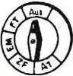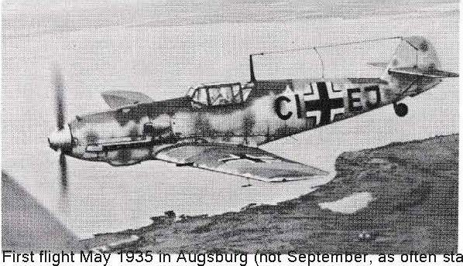Headphone socket for FuG 16 un its, with volume control and switch.
- Remote control unit for frequency alignment.
- Remote switch for the detented operating frequencies of the FuG 16 ZY: 1 Y- command frequency, 11 group command frequency, 111 air traffic control frequency (close range), 1V general fighter frequency (Reichsjäger frequency).
- Remote switch for the operating modes of the FuG 16 ZY with the positions: A1 (control), ZF (homing), EM (range finding and communication), FT (communication), Off.

Figure 3.10 Fighter aircraft Messerschmitt Me 109.
ted). Wing span 9.90 m, length
8.70 to 9.00 m. Equipped with a 12-cylinder Daimler-Benz engine, which was also used for ltalian fighter planes: 1100 kilowatts, later even 1300 kW (approx. 1500 or 1800 hp). Range approx. 700 km. The Me 109 continued to be built after 1945 in Czechoslovakia as the S 99 and in Spain as the HA 1 1 12. lt was in service with the Spanish Air Force until 1965; one example of this fighter still flies at Messer schmitt-Bölkow-Blohm today (1983, registration D- F MBB). 1n total, 35,000 Me 109s were built, the largest number in the history of fighter aircraft. The on-board radio system of the Me 109 included the FuG 16 ZY radio, with which homing and fighter guidance was possible. Many Me 109s were also equipped with the FuG 25a friend/foe radio. Both radios were installed in the fuselage approximately where the crossbeam can be seen, accessible through a "manhole" in the side wall. The transmitter of the FuG 16 ZY worked with the T-antenna stretched from the mast to the fin; the receiver had a rod antenna mounted on the underside of the aircraft. 1 n the direction of the letters Cl, the rod antenna of the FuG 25a was located at the bottom and the homing frame of the FuG 16 ZY was located at the top.

36

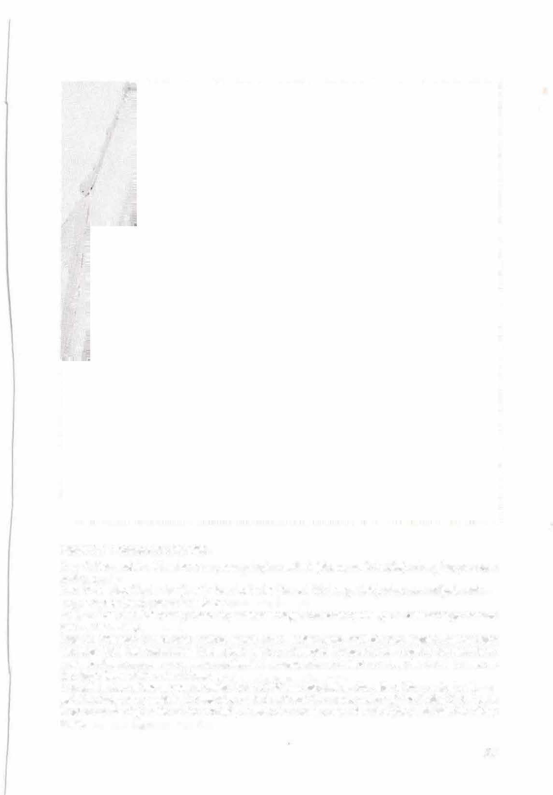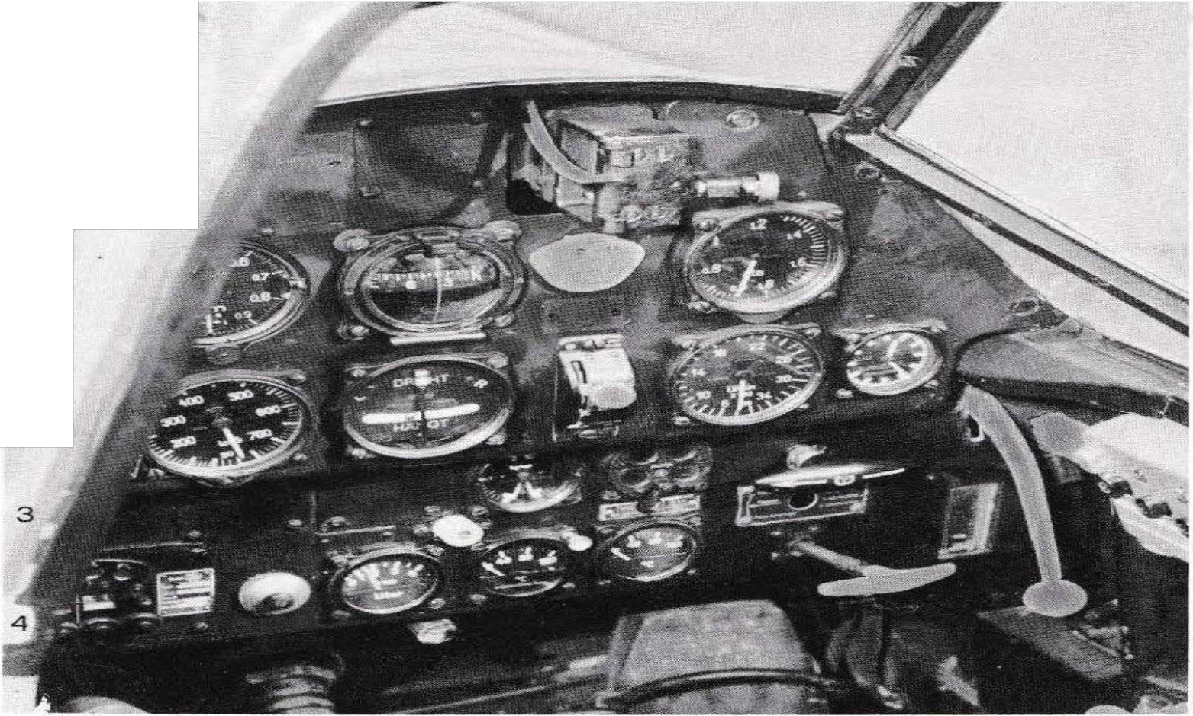/f

I
l
J
I
2

Figure 3. 11 Cockpit of a Me 109.
Une 1: Barometrie altimeter; compass; plug-in contact (above revi- holder); charging pressure indicator.
Une 2: Airspeed indicator (km/h); turn indicator (turns UR; hangs UR), airscrew- adjustment
engine speed (rpm) ; airscrew position.
Line 3: Fuel and lubricant pressure; undercarriage indicator (on/off); undercarriage handle (on - rest - off).
Une 4: Weapon switch and control panel; push button zero shut-off; fuel supply, upper right warning light for remaining fuel ("red light"); lubricant temperature, coolant temperature; undercarriage emergency cable; mechanical undercarriage indicator; lever for hand pump; on the right side wall the circuit breakers.
The talk button of the on-board radio FuG 16 ZY was located on the side of the control unit.
pel. The frequency switch, the remote control unit and the mode switch of the FuG 1 6 ZY were located on the right side of the cockpit, as was the remote control unit of the FuG 25a friend/foe radio.

37

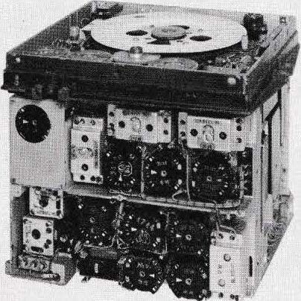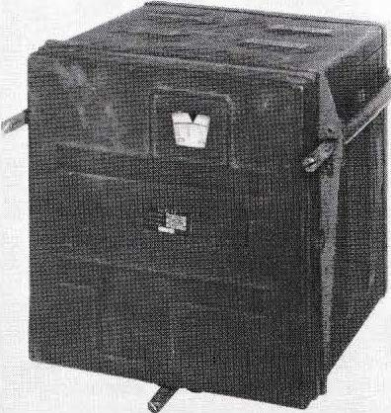Other U KW on-board radios
Of the U 'rQ./V on-board radios developed by Lorenz, the following types should be mentioned:
FuG 1 S, a 6-wa tt transceiver (transmitter-receiver wit h common oscillator), had remote control for 200 keyed channels in th e range 37.80 - 47. 75 M Hz, double super, switching for AM/FM (A 3/ F3).
FuG 18 was a transceiver development for universal use, with 1 020 channels in the range 24 to 75 M Hz, of which 6 operating channels could be locked. Mode of operation was A3, F3, A2 and homing to omnidirectional transmitters, landing beacons and rotating beacons. Transmitting power 15 Wa tt. Cone-loop variometers were used for exact tuning of the wide frequency range.
FuG 24, a highly simplified 5 -watt on-board radio. The transmitter operated on two remotely switchable frequencies in the range 38 to 45 MHz; the receiver had a continuously tunable range from 30 to 45 MHz, which could also be used to pick up the landing beacons and the talking rotating beacon "Hermine". The operating mode was A 3 and homing.

Figure 3.12 Remote-controlled on-board radio FuG 15 (Christa)

38

14 „15
/
H H z
Em l_f ä, i er

Recever
Hischer

ZF-Disturber 1 41 MHz

Lim ter NF-Verstötktr

500 HI -Antrieb
. �--
s r

sender

leg etg rin ding vi
r i o m e t e r

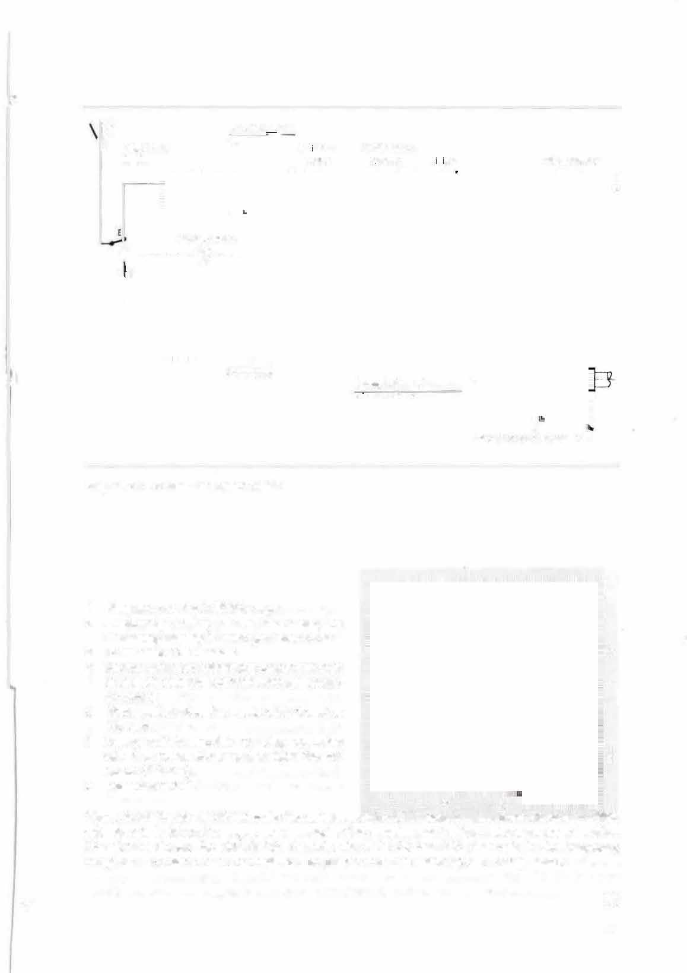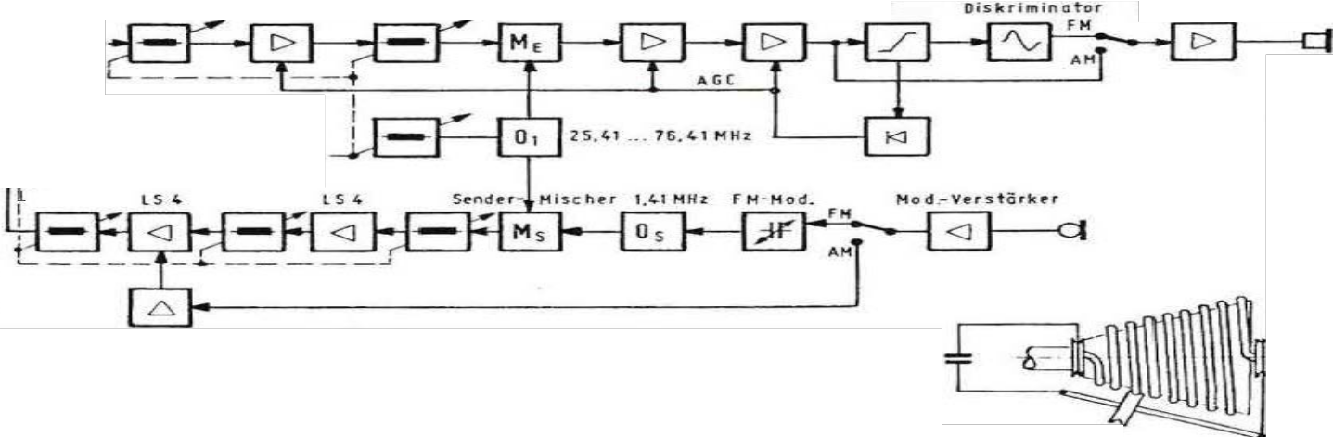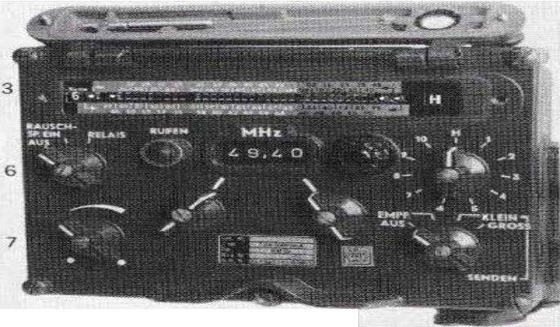
I
Stro m o b n a h m e roll

Figure 3.13 FuG 18 on-board radio

- Frequency setting in 50 kHz steps
- Frequency setting in 1-M Hz steps; the frequency display is arranged above this.
- Preset any 10 channels 3
- Rotary switch for selecting a preset channel;
to the left of it 'an indicator lamp as switch­ 4
on control.
- Mode switch: Receive, send with 1 watt or
15 watts.
- Rotary switch: squelch or relay operation
with two transceivers; to the right the call 5
button (1.6 kHz).
- Volume control.
2 1
Figure 3.14 The S EM 25 FM radio for vehicles, which SEL began mass production of in 1960, was able to build on the experience gained in the development of the Lorenz on-board radios. The picture shows the detachable control unit. SEM 25 has 880 channels in the frequency range 26 - 70 MHz. Ten channels can be preset and then selected with a step switch.
, 39

4 Direction finder PeilG 6 with direction finder receiver EZ 6

The DFG 6, introduced in 1 942/43, was used for taking bearings, for carrying out target flights and for broadcast reception, in each case in the frequency range 1 50- 1 200 kHz, on transmitters of a 11 the then usual operating modes A 1, A2, A3.
The soundings could be carried out according tothe following methods: 1. As
Hand-held minimu m direction finding with headphones. 2. as a hand-guided !'. traverse
Comparison sounding with minimum display on the instrument AFN 2 (Fig. 4.5), if required also with headphones. 3. 3. with the automatic bearing supplement APZ 6 automatic comparison bearing with display on the bearing compass ( Fi g. 4.3}.
4. homing was possible according to the AF N 2 indicator or the bearing compass.
The EZ 6 direction finder receiver ( Fig. 4.1) was an essential component of the PeilG 6. lt was constructed in the proven FuG 10 design and could be used in the FuG 10 system instead of the long-wave receiver. The radio station thus upgraded fordirection finding operation was then designated FuG 10 P.
A flat fram e anten na with ma ny turns and an H F i r o n co r e served as a horizontal DF antenna, based on the principle of today's ferrite antennas, albeitwith a length of approx. 30 cm. The S-shaped double-circuit directional diagram associated with such antennas is given a sharper minimum by adding a small non-directional auxiliary antenna in the correct phase. The required magnitude of the auxiliary antenna voltage was set on the EZ 6 with the rotary knob " De-cloud1mg".
The direction finding antenna was motor driven and could be switched to left or
right rotation with a manually operated control switch ( Fig. 4. 3} to find the bearing mini m um. In the case of automatic bea ring an d t arget fl ight according to beari ng compass, th e ante nn a was automatically steered to the bearing mini m um.
For a ta rget flight according to the instruction, the d irecti on fin der antenn a is set in the "ahead" direction. At the same time, any crosswind influence can be taken into account by a slight correction of the antenna position (windward setting).
For omnidirectional reception in the long wave range 300 - 600 kHz, the fixed or trailing antenna of the Fu G 1 0 was switched on.

40 t.

1
Figure 4.1 DF receiver EZ6. 1 2 3
'
1

- Operating mode switch:
Frequencies, A2 (and A3), A1 with bandwidth setting (400- 2400 Hz).
- Frequency scale, below double knob for frequency tuning coarse (inside) and fine (outside).
- Density of the minimum. Below, frequency range switch: 150-300 kHz; 300
-600 kHz; 600-1 200 kHz.
- Switch for minimum bearing, comparison bearing and homing, broadcast reception.
- Connection for test unit
PV10.
- Headphone jack for
testing purposes. 7 6 5 4
- Volume control.

The direction finder receiver EZ 6 was a superheterodyne receiver built by Telefunken vvith the classic construction: HF stage, mixer stage, oscillator, t\/1/0 IF stages (1 30 kHz), telegraphy superimposer (2nd oscillator), rectifier (demo dulator), AF stage. All seven tubes were of the type RV 12 P 2000. As a special feature, it should be mentioned that this receiver had a crystal filter in the IF section; furthermore, the second oscillator was crystal controlled (131 kHz), and its harmonic 262 kHz was used for calibrating the scale (svvitch position calibrate).
1

Direction finding antennaMotor switch H fs antenna

IP:. • r ;f! ,.HF-, ZF-. �F- 1 1--

♦----· : 1, ..•, '"l:.:.l=:fia"::....
.,-- w
K A

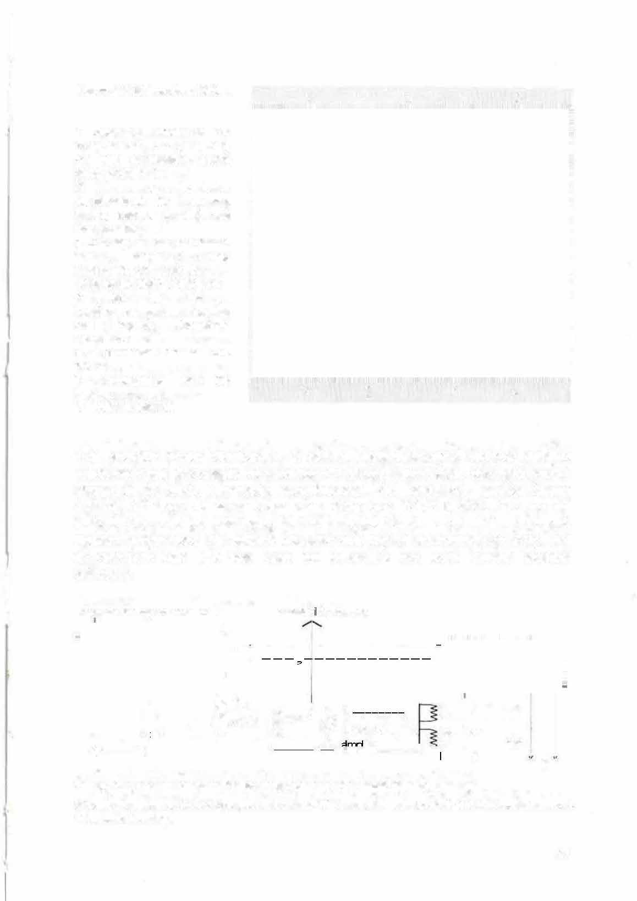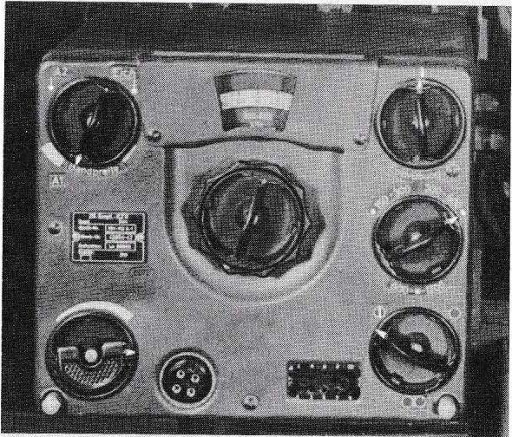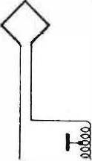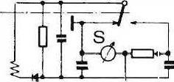To Fig. 4.1: EZ6 on comparative bearing (bearing with visual display; homing).
S Vertical pointer of AFN 2 (course indication); W Horizontal pointer of AFN 2; K Headphones; A Automatie bearing.

41

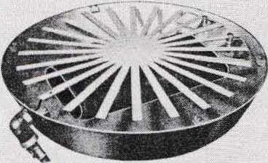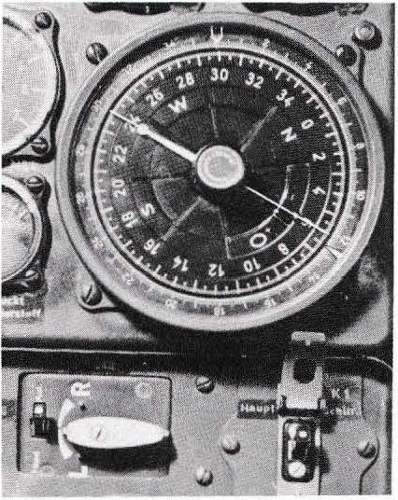During comparison bearing and target flight, a motor switch in the EZ 6 switches the bearing antenna connections at the receiver input 100 times a second. When the direction finding antenna supplied a voltage, the auxiliary antenna voltage constantly applied to the receiver input was modulated at 50 Hz. The result was that the 1 kHz tone delivered from the receiver output to the headphones trilled at a rate of 50 Hz. This trilling was a signal that the DF antenna was not at minimum or that there was a course deviation. At the minimum bearing (and with the correct heading), no voltage was induced in the DF antenna, so there was no 50 Hz modulation, and the 1 kHz tone was heard vvithout trilling.
For the visual display, the 50 Hz modulation caused by the motor switch was fed to the AFN 2 display unit via a rectifier arrangement controlled by the motor svvitch and produced the right or left display depending on the phase position of the DF antenna voltage. At the bearing minimum, however, the 50 Hz modulation was missing, no direct current was generated and the pointer remained in the centre position. The DC voltage for the instrument was also used as a criterion for the automatic bearing vvith display on the bearing compass.

Figure 4.2 Rotating DF antenna of the PeilG 6, with star-shaped auxiliary antenna on the Plexiglas bonnet. Below the DF antenna was the remote-controlled drive motor with worm gear. On the left the auxiliary antenna connection.

Figure 4.3 Direction finding compass (Patin radio direction finding compass).
0
Outer 360 division: §ide bearing rose, top the control b�r (0 ).
Inner 360 -division: compass rose (course rose), indicating the adjacent course on the rudder line.
In the centre: Adju stment knob for misalignment and deviation.
The bearing pointer rotates synchronously with the bearing antenna and indicates the direction to the bearing transmitter.
indicates "direction finding". On the outer rose, the side bearing mark that accompanies the bearing pointer indicates the "loaded radio side bearing".
Below the bearing compass: the bearing antenna control switch ( L/ R) with toggle switch
"Manual bearing/ Automatie bearing". Another version is shown in figure 4.4.
42

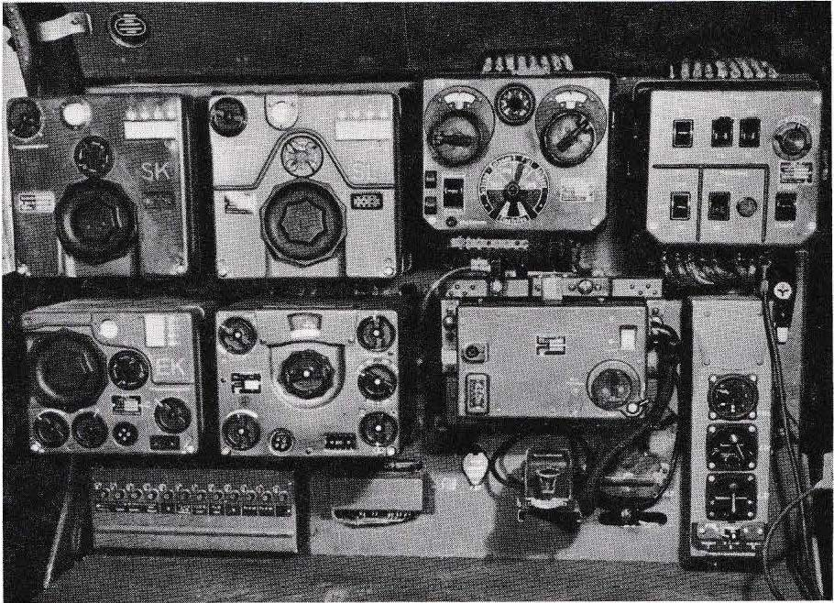l
1

Figure 4.4 On board radio system FuG 10 P (with bearing receiver EZ 6) and landing receiver EBI 3.
Top row: shortwave transmitter SK, longwave transmitter SL, remote control unit, radio operator control box. Bottom row: shortwave receiver EK, direction finder receiver EZ 6 (also longwave receiver), landing receiver EBI 3. Directly above the radio operator's desk: circuit breakers on the left, Morse key and instrument panel on the right On top the display unit AFN 2 for bearing, homing and landing approach. Below it, bearing switch (manual or automatic bearing), bearing antenna control switch (L/R) and frequency switch.

Direction finder PeilG 5
The predecessor of the PeilG 6 with EZ 6 was the PeilG 5 with the bearing receiver EZ 2 and a mechanical remote control unit (flexible shafts and Bowden cables).
The PeilG 5 provided a different acoustic signal than the PeilG 6: In the event of a course deviation (minimum deviation), Morse code signals were audible in the headphones, namely the letter A (di dah) in the event of a course deviation to the right, and the letter N (dah dit) in the event of a deviation to the left. lf the course was kept exactly (exact minimum position), the two complementary Morse code signals complemented each other to form a continuous tone.

43

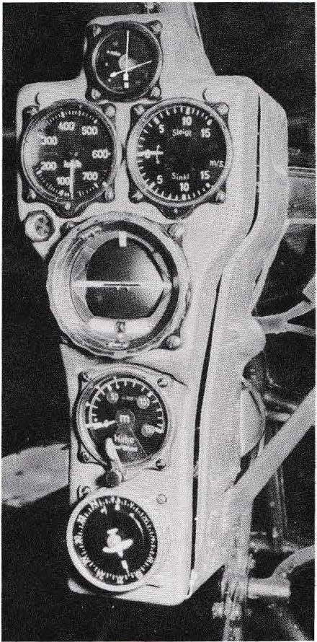Before the introduction of the DF antenna with HF iron core ( 194 0), the circular DF frame with 1 - 2 windings, which was generally used until then, was used with the DFG 5. A rod antenna of 80 cm length served as an auxiliary antenna, which was usually accommodated in the antenna mast of the aircraft and was also used for the landing course receiver EBI 1.
The EZ 2 and EZ 6 direction finders were developed at Telefunken by groups of engineers led by Dr Günther Ulbricht.

Above: AFN 2 indicator, switchable to FuG 16, radio landing system and direction finder. The vertical pointer flipped out during homing or landing if the aircraft deviated from the correct course; during direction finding it indicated the minimum position of the rotatable direction finding antenna. The inclined pointer flipped upwards when approaching the ground station transmitter. 1 n the centre a glow 1am p which lit up when flying over the pre-flight mark and the main arrival mark (see section 5).
Side by side: airspeed indicator (km/h) and variometer (climb/descent).
Artificial horizon for blind flight. In the centre the fixed aircraft symbol. The moving horizon shows whether the aircraft is horizontal or in which direction the longitudinal and transverse axes are inclined (the horizon is then higher or lower than the aircraft symbol and inclined to the left or right).
Display instrument of the radio altimeter FuG 101a. Switching knob for switching the measuring range from 150 m to 750 m; control knob for checking and, if necessary, readjusting the display (see section 10).
Below: Compass display.

Figure 4.5 Flight monitoring instruments in front of the pilot's seat of a Ju 188.

44


The radio landing systems

Radio landing systems have the task of providing the pilot with a clear view of the ground,
z. The pilot must be able to indicate the correct approach course to the runway,
e.g. in darkness or bad weather, and provide distance information so that he can reduce his altitude correctly on approach.
From 1934 onwards, German airfields were equipped with the Lorenz landing system, which worked in the VHF range. lt consisted of a beacon transmitter, which indicated the exact landing course, as wen as two entry marker transmitters, which stood 3000 m and 300 m in front of the runway and radiated vertically upwards as distance markers (pre-entry marker and main entry marker). Otto Scheller, Lorenz's technical director, received the basic patent for the guidance beam method as early as 1907. Building on this, Prof. Ernst Kramar developed the Lorenz landing method in 1932, which led the way for the instrument landing system (ILS) later introduced at airports in all countries (Figure 5.6).

On board the aircraft, the radio landing system consisted of the guidance beam receiver and the entry signal receiver. The EBI 1 beacon receiver had two remotely switchable frequencies in the range of 30-33.3 MHz for receiving the landing course transmitter; range approx. 100 km. The pilot received both acoustic and optical heading information: The homing instrument shown in Figure
4.5 was switched over to the radio landing system for the landing approach. lts course pointer was vertical and pointed to the target marker du ring an accurate jet approach. lf it swung to the side, the pilot had to correct the flown course until the pointer was vertical again. In addition, the deviation from the beam could be heard in Morse code in the headphones: dots to the left of the beam on approach, dashes to the right of the beam, and a continuous tone when the course was correct.
The EBI 2 entry signal receiver was designed for the 38 MHz frequency used by the pre-entry and main entry signal transmitters. \/Vhen flying over the pre-flight marker, the pilot heard 700 Hz tones and at the main approach marker 1700 Hz tones. He then knew that he was 3000 m or 300 m ahead of the runway and could adjust the altitude for the landing approach accordingly. As a visual signal, a lamp in the centre of the target flight instrument lit up when flying over the entry markers.

45

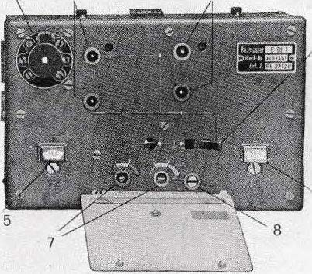The two receivers EBI 1 and EBI 2 together formed the radio landing system FuBI 1, with which all multi-engine aircraft were equipped (developed by Dr Johannsen/Lorenz).

2 3

4

Figure 5.1
EBI 1 guide beam receiver, cover flap open.
1 antenna connection, 2 HF tuning,
6 3 Audio tuning, 4 Frequency switching
5 frequency 1, 6 frequency 11, 7 feedback (1 and II), 8 switch. (The single sign receiver EBL2 can be seen in figure 3.6).

From 19 41 onwards, the guide beam receiver EBl3 developed by Dr. Kloepfer/Lorenz was used instead of the EBI 1 ( Fig. 5.2 and 4. 4) lt was a superheterodyne receiver with higher sensitivity and greater range, tunable to 33 channels in the frequency range 30-33.3 MHz; tuning ·by hand,
later also remote controlled. Together with the single-flight signal receiver EBI 2, it formed the radio landing system FuBI 2. The EBI 3 consisted of the following stages, all equipped with RV 12 P2000 tubes: HF stage, mixing stage, oscillator,
- IF stages, demodulator (rectifier). The circuitry and design were similar to those of the proven FuG16 receiver.
The radio landing systems were a safe aid for landing at night or with low cloud cover. The actual touchdown could then usually take place in direct visibility, at night with the help of the aerodrome lighting. Dramatic situations arose, however, when the air traffic control officer refused to switch on the aerodrome lighting, even for a short time, because of the air traffic alarm (Müo).
At the end of 19 44, the frequency of the two flight mark transmitters was moved to the reception range of the EBI 3, so that the EBI 2 receiver could be dispensed with. In addition, in connection with the fighter landing procedure, the distance of the flight mark transmitters was reduced to 20 km and 3 km from the runway. enlarged. Together with the LF amplifier and FuG 16, the EBI 3 resulted in the combined navigation and communication system FuG 125. This combination, which was mainly used by fighters in bad weather, was used for message reception and homing (FuG 16), as a radio landing system, and for navigation with the FuG 1 25.
46

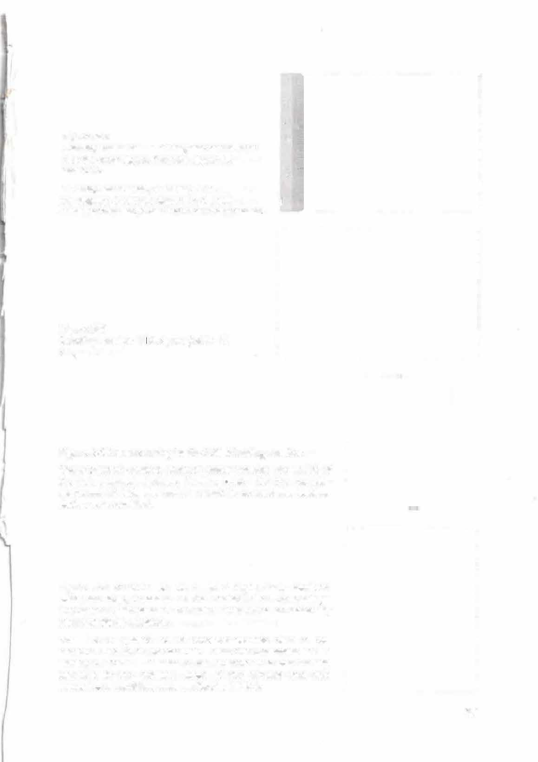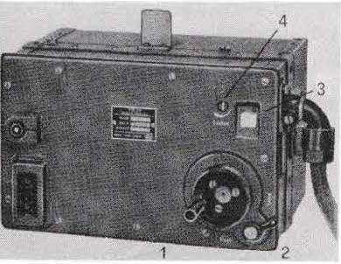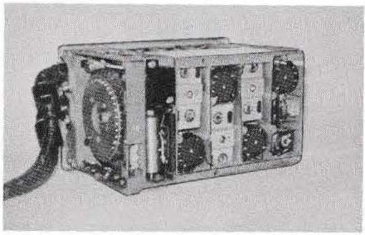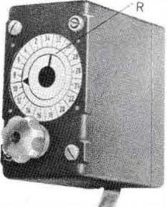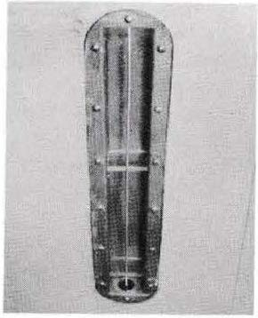

Figure 5.2 5
Landing receiver EBI 3 for guide beam. later also for entry signs. See also figure 4.4
and 6.14. 6
1 Tuning crank knob, 2 Brakes, 3 Ka-
nal display, 4 volume adjusters, 5 aerial
cable connection, 6 test instrument connection.

Figure 5.3
Landing receiver EB 3, open. (width 27 cm)

Figure 5.4 Remote tuning for the E BI 3 landing receiver.
Outer pointer: desired channel. Inner pointer: Feedback of the set channel. Bottom: Tuning knob. On the remote­ controlled E B13, the tuning cran k knob and the locking device were omitted.

Figure 5.5 Antenna of the E BI 2 flight mark receiver: Excitation loop, recessed on the underside of the fuselage and covered with plastic. The older version was an externally mounted dipole antenna.
The EBI 3 guided beam receiver worked with a rod antenna that could be extended from the underside of the fuselage. The EBI 1 used a rod antenna that was usually mounted in the antenna mast of the aircraft and also served as an auxiliary antenna for the DFG 5.

47

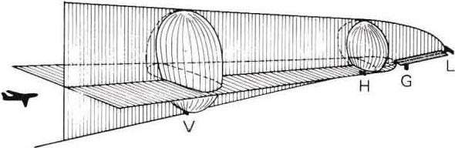This was done vvith the help of the Hermine radio beacon, which transmitted in the 30 - 33.3 M Hz range. Because of its high sensitivity, the EBI 3 was also used to receive the Knickebein beacon; at an altitude of 6000 m, a range of approx. 500 km could be achieved with this receiver.

L Landing course transmitter, 108-
1 12 MHz
G Glide path transmitter, 329 - 335
0
MHz, glide angle approx. 3 V Pre-flight signal,75 MHz, 7
km before the runway
H Main approach mark, 75 MHz, 1 km before the runway
Figure 56 The instrument landing system I LS, introduced worldwide in 1 946.
An instrument shows the pilot whether the aircraft is correctly following the landing course and whether it is in the glide path. When flying over the entry marker, a lamp lights up and an acoustic signal sounds at the same time.

The instrument landing system I LS (Figure 5.6), which was introduced worldvvide in 19 46, is based on the Lorenz landing system mentioned at the beginning, for which Prof. Kramar was also able to create a straight-line glide path plane in 19
36. On board, a combined pointer instrument shows the pilot whether the aircraft is on the correct landing course and whether it is in the glide path plane (Figure 5. 7). 1 n addition, the pilot receives visual and acoustic information as he flies over the approach markers.
Other short- and medium-range navigation techniques that have been introduced include VOR, DME and TACAN. The VO R rotating beacon transmits in the 108
- 118 MHz range and enables the aircraft to determine direction (azimuth) and to fly on any radial course to or from a VOR ground facility. The instrument used for I LS (Figure 5.7) is used for display.
The location of the aircraft is determined from the intersection of the radial lines of tVvO ground systems. DVO R, Doppler VOR, is also suitable for unfavourable terrain vvith reflecting obstacles. DME is a distance measuring
which operates in the range 9 60-1215 MHz; display on board is in
Digit form. The combination VO R/DME enables civil aircraft to determine their position from direction and distance. TACAN, also in the 9 60- 121 5 MHz range, is a military navigation procedure that provides the aircraft vvith direction, distance and thus location. VO RTAG is a combination of VOR and TACAN range finding procedures for civil aviation.
48

Figure 5.7 Combined display unit for Instrument Landing System I LS, VOR rotating beacon and compass.
In the middle of the display unit is the fixed
symbol of one's own aircraft. lnscrib- G
o 0
of the compass rose corresponds to up to 360 . s 0
The glide path indicators G are higher than the aircraft in the picture and thus indicate that the aircraft is to
St M

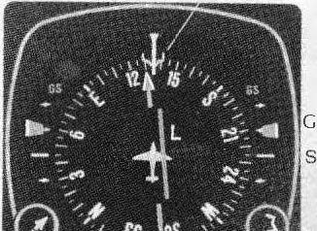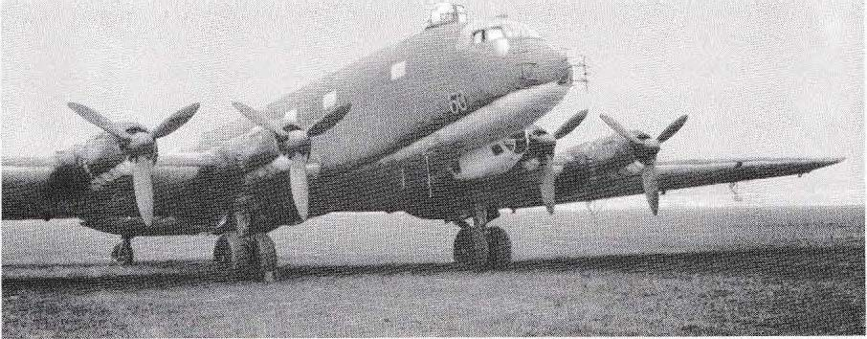flies low. lf the aircraft flies exactly in the glide 2
When the glider is flying on the ground level, the glide path indicators are at the S markers.
Turn control knob 1 to move the set course pointer (arrow) to the desired course at the relevant ILS.
0
The landil)g course is set to the course prescribed by the situation, in the picture to 130. (The set course pointer tums
with the compass rose). With knob 2, the M mark has been set to 135,
to allow for crosswinds from the right. The mark rotates with the compass rose and is shown in the picture under the control line St (longitudinal axis of the aircraft). The bar L symbolises the position of the guide beam and shows in the picture that the aircraft is currently still to the left of the guide beam. The aircraft must therefore be steered to the light until the bar L comes close to the aircraft symbol and flushes with the arrow.

Picture 5. 8 Junkers Ju 290, four-engined long-range aircraft.
First flight at the beginning of 1 941 , length 28.80 m, wingspan 42 m. Double rudder, similar to Fig.
7. 9. Four air-cooled 1 4-cylinder double-star engines by BMW, each 1 250 kilowatts (1700 hp),
range 6000 to 7000 km. The radios of this long-range reconnaissance aircraft
and their arrangement at the workstation of the on-board radio are shown in figure 3.6 and 6. 14.
The fuselage also contained the transmitter of the FuG 216 (2 1 7 ) "Neptun" as well as the transmitter and receiver of the FuG 200 "Hohentwiel" (Fig. 6. 7). The antennas of the FuG 200 radar unit are visible on the bow.

49


- The radar unit ( radio measuring device) Hohentwiel

The FuG 2 00, especially known under lhe name "Hohentwiel", was an aclive radar device (then called a radio measuring device) wilh which ships, boats and even small objecls such as life rafls could be searched for from lhe aircrafl. From mid-1 943 onwards, this ship detector was filled in particular in all Bv 2 22, Fw 2 00, He 1 77, Ju 2 90 maritime patrol aircraft, as well as in Bv 1 38, He 1 1 1 , He 1 1 5 , Ju 88, Ju 1 88, Ju 388. The detected object was displayed on the screen of an oscilloscope tube as a bright spike on a distance scale (Fig. 6. 3). At the same time il was possible to see whether il was in lhe direction of flight or to lhe side (homing device wilh dislance measuremenl).
Principle of distance measurement: The radar lransmils high-frequency waves for a short time wilh a directional antenna; when il hils an object, part oflhe wave energy is reflecled and a traction of il reaches the receiver of lhe radar as an echo. Since lhe propagation speed of radio waves is known (300 000 km/s), the dislance results from the lransil time "transmiller - object - receiver". For example, wilh a propagation time of 1 millisecond, lhe total dislance (H i-n and return) is 300 km, and the dislance from lhe radar uni! lo the reflecting objecl is 15 0 km. The transil time is displayed by an oscilloscope: Al the beginning of the transmission, lhe beam deflection also begins, caused by a vollage on the time plales, and at the momenl the echo a rri ves a t the receiver the measuring plates deflecl the electron beam at right angles, so thal a luminous spike appears on the screen (Fig. 6.3). The time axis of the oscilloscope is calibraled direclly in kilo-metres, so !hat no conversion is necessary for the reading.
Principle of dire ctionaI in dication: The receiver of the FuG 2 00 worked wilh two directional antennas whose radiation lobes devialed 30' lo the left and righl from lhe longitudinal axis ofthe aircraft (Fig. 6. 5). lflhe larget is in the direction offlighl, each antenna picks up lhe same amounl of reflecled energy, and lhe same size of light spikes appear on lhe screen to the left and righl of lhe cenlre line. lf, on the olher hand, lhe largel lies lo lhe side, one anlenna absorbs more energy lhan lhe other, and accordinglythe one spike becomes larger than the other.

50

Figure 6.1 Long-range reconnaissance aircraft with Hohentwiel antennas. Above the two receiving antennas, below in the middle the transmitting antenna (cf. Fig. 6.6 and 5. 81).

Figure 6. 2 Hohentwiel display unit with picture tube for distance and direction indication (width 15 cm).
On the left the adjusting knob for brightness, on the right a rotary switch for the distance range was added later: kilometre/hectometer. Above, the coverable adjusters for sharpness (right) and zero (left), as weil as the connection for the testing device (middle.

2

Figure 6.3 Screen display of the Hohentwiel radio measuring device
Land destinations left Sea target exactly ahead Sea destinations left

km
1 50 1 5
1 00 1 0
70 7
50 5
40 4
30 3
20 2
1 0

Sea target ahead on the right Noise level ofthe receiver
Start impulse and "sea serpent".
- --
' --
3
4
� 0 0

1- 51

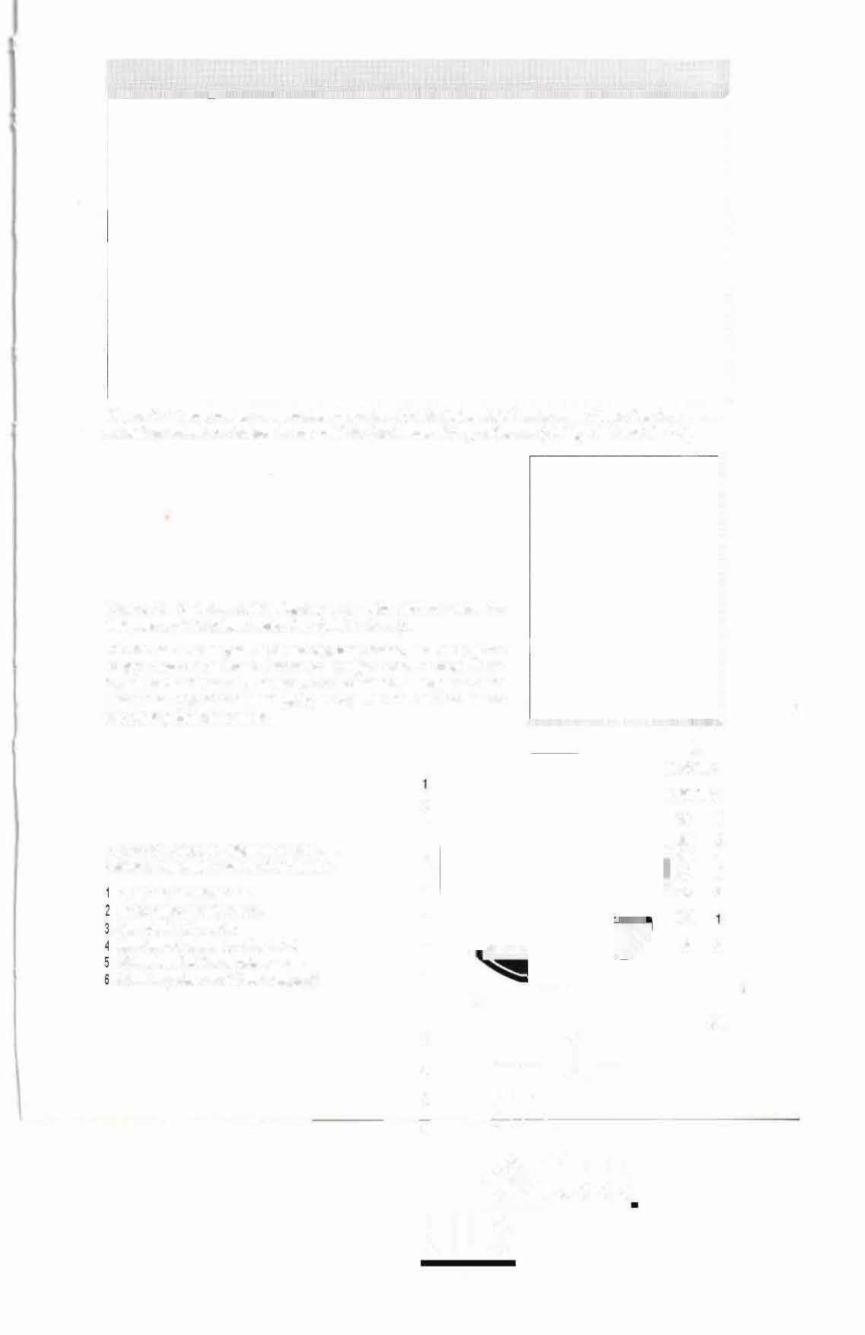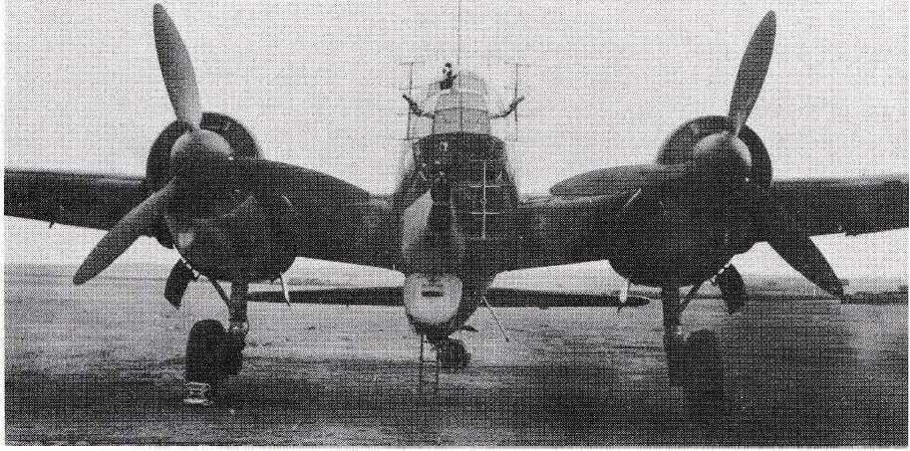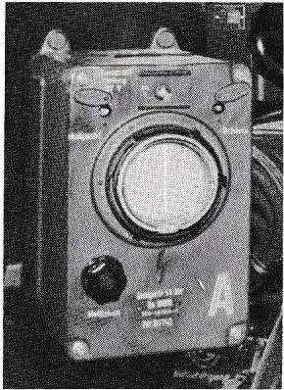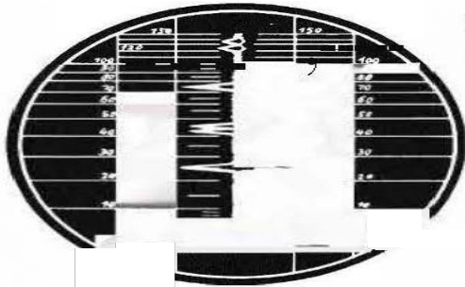: -�1 111 ..
♦
ll! ! !
! l lt

The radar set "Hohentwiel" operated in the frequency range 550 MHz (54.5 cm), i e. in today's UHF television frequency range. The transmitterwas put into operation by applying the anode voltage for 1.5 µs at a time (anodentastu ng). The follow-up time of the 1,5 µs pulse was 20 ms (Fig. 6.4), the pulse frequency was 50 Hz. Two decimetl'e• wave trio des R D 1 2 Tfin push-pull circuit served as emitters, which delivered an HF power of 35 kW. The anode probe voltage was generated ve1y rationally with a single­ stage high-power toggle device, which also determined the pulse frequency: charging of a capacitor, which discharged abruptly via a thyratron when a certain vo !tage was
reached. The discharge current surge (peak value approx. 800 A) generated the voltage surge of 10 kV and approx. 1.5 µs duration in an impulse transformer for the anode key of the transmitter. The entire switching of the FuG 200 was designed for minimum power and tube requirements, so only 800 'vV were drawn from the on-board power supply despite the high transmitting power.

HI �1 ------· -<1pprox. 550 MHz
+i.. " -- ·•1lrniiiiil1I-,
_ - 20ms so Hz-- - - - J • _

Figure 6. 4 Pu ses transmitted by the FuG 200 (pr nc ple il lustratj on).



Th�ereceiver was a double superhet with mixed diode input, 1 st IF = 8.4 MHz,
2.IF = 6 .3 MHz, bandwidth 0.7 MHz, later 1 2 MHz_ lts output voltage controlled the measuring plates ofthe oscilloscope tube in the display unit(jag generation)_

Antennas: The transmitting antenna radiating in the direction of flight and the two receiving antennas arranged offset consisted of dipole groups of the same design (Fig. 6 .6 )- With a motor switch, the left or right receiving antenna was switched on alternately in quick succ ession, so that the receiver alternately evaluated the left or right light diagram_ (The transmitter was disabled during the switching
°
process.) Some of the aircraft \lvere additionally equipped with 90 sideways
pointing antennas, e_g. for coastal flybys_
The range of the FuG 200 \Aras approx. 80 km for medium-sized ships and up to 1 SO km for large land targets, e_g. steep coasts. On the monitor, a range ofO to 1 SO km was recorded, which could be switched to close range_
0 to 15 km, at which the measurement deviation \Aras only ± SO m Target accuracy was ± 1 °; close-up resolution of the first instruments started at 1.7
km, later already at 800 metres. The scale was divided I ogarithmically, so that the desired increased accuracy was achieved at short distances. By switching on a running timeelement • as it was also used in the Fa rb-

52

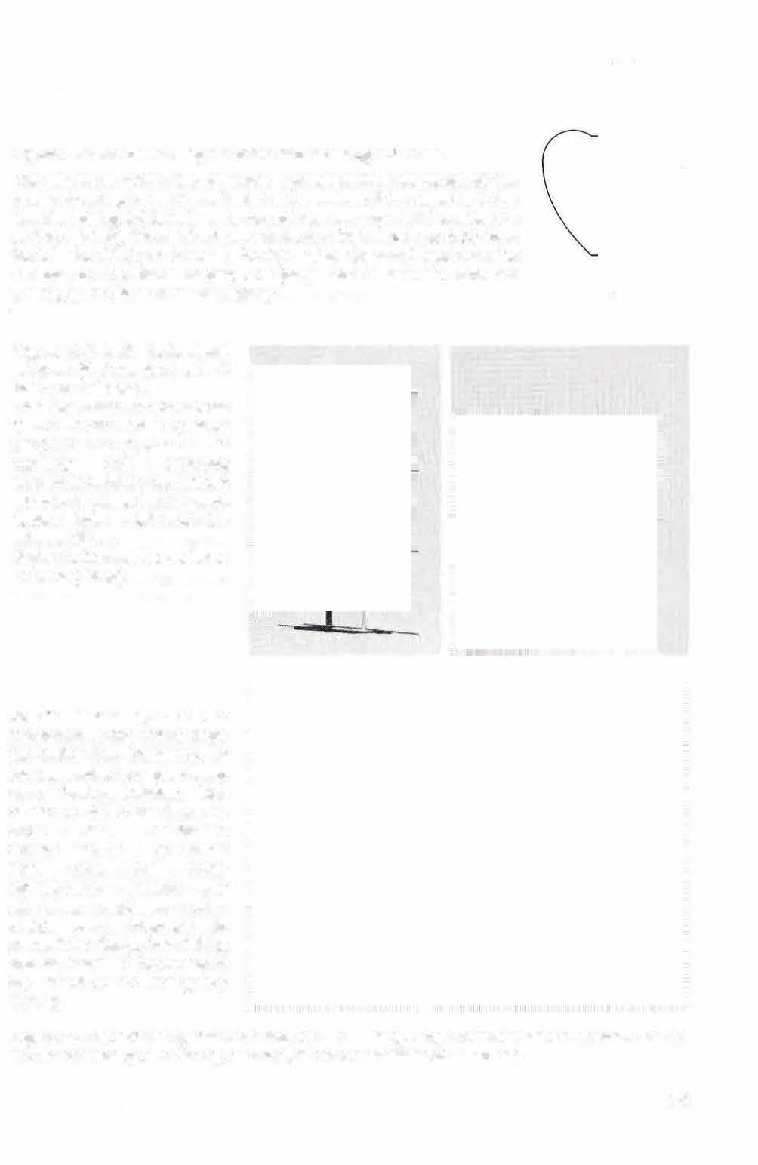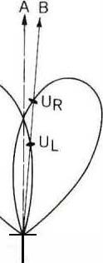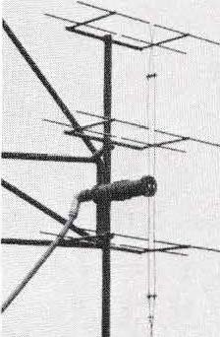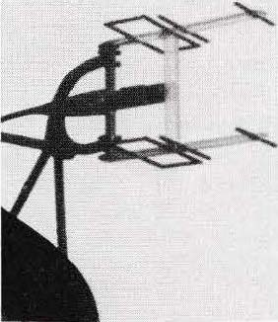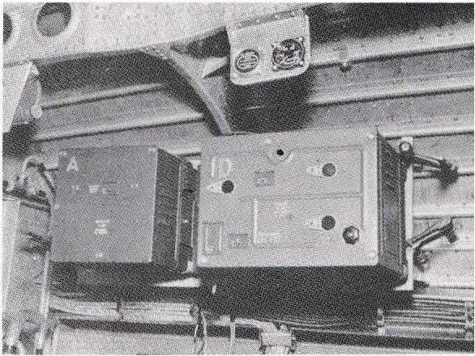Figure 6.5 Directional diagram of the two receiving antennas.
The distances within the diagrams symbolise the magnitude of the received voltage when the reflected pulse arrives: lf the object is in the direction of flight (A), both antenna voltages are equal. lf the object is on the right (B), the right antenna delivers a higher voltage (UR) than the left one (U L); as a result, the right spike appears !arger than the left one on the visual display unit (amplitude comparison direction finding, guide plane direction finding).

Figure 6.6 Left: Hohentwiel antenna (first version) with 8 half-wave dipoles.
The feed lines are connected to the dipole ends (voltage feed). In the middle is the matching and balancing element to the antenna cable. A reflector is placed behind each dipole. Total width of the antenna 52 cm.
Right: Hohentwiel broadband antenna (Wren)

At the bottom right of the transmitter is the rotary knob for setting the frequency, at the top centre is a glow lamp as a tuning indicator. Also visible on the transmitter are three test equipment connections with protective flaps and the three conspicuous holders for attaching explosive sets, which were intended to prevent the device from falling into the hands of the enemy in the event of an emergency landing.
Figure 6.7 Hohentwiel system installed in a Ju 290 long-range reconnaissance aircraft. On the left the receiver (width 25 cm), on the right the transmitter (width 36 cm).

53

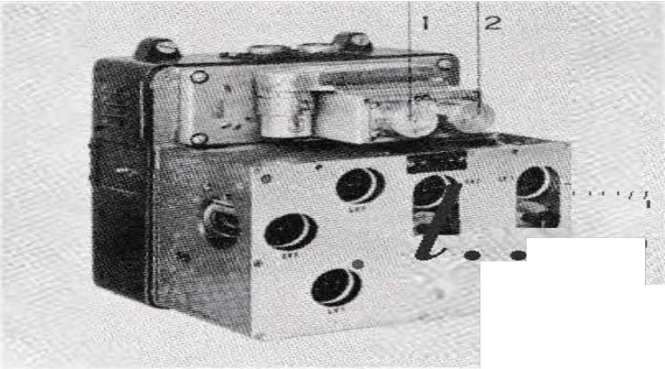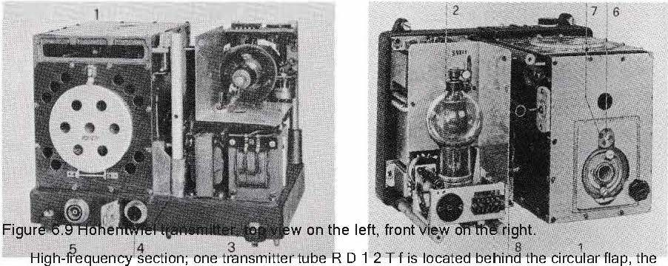The calibration of the distance scale could also be controlled in flight and the device adjusted to the highest accuracy and sensitivity (reflections at the end of a glass body created artificial target spikes at 3km intervals).

In order to avoid enemy jammers, the Hohentwiel systems were set to different frequencies (scatter waves) in the range of 550 MHz in 1 944. For further series of devices, it was possible to choose between two fixed frequencies before the start. At the end of 1 944, systems were also added in which transmitters

Figure 6.8 Hohentwiel receiver
Above the connections for the two antenna cables. 1 Mixing diode LG 7, 2 Oscillator
triode LD 1 , 3 diode LG 1 (also to the left), '
furthermore 7 pentodes LV1 are visible.
3 1

2

second transmitter tube is accessible from behind in the same way. 2 Thyratron, 3 Transformers (02, 03), 4 Wave meter diode LG 1, 5 Connection for the antenna
(lable, 6 frequency setting, 7 slip clutch, 8 rectifier tube LG 12.

54

and receiver were continuously tunable with the remote control unit in one of the following ranges: 475 - SOS MHz, SOS - 525 MHz or 545 - 565 MHz. These units had corresponding broadband antennas ( Fig. 6. 6). In retrospect, the FuG 200 was significantly less susceptible to interference than other radio measuring instruments.
The FuG 200 "Hohentwiel" was developed and tested by Lorenz in 1 942. The transmitter was based on the previously built FuMG 40 L flak radars.

Figure 6.1 0 Remote control unit
In the top centre is the transmitter on/off switch, below it is the rotary knob for setting the receiver amplification. On the left, the switch for the transmission frequency, on the right, tuning of the receiver.

Transmilting antenna *"TU*
I

.,,, <
\
...,.i_

Receiving antennas

/ -7 Motor switch lefl/right
J_,,
550MHz, 1.5 µs. 35kW (2 Mixed stage (LG 7)

x RD12 Tf)

1 .5µs, 50Hz:, 10kV, SODA

::r:

ich
0sc llator (LD 11 cali bration device IF
amplifier

(Thyratron S1/3ill: LG 12) generator
ZA T me def ection (LV1) l
HS Healing control (LV1) �
L

1 1
H Brighlness S Sharpness _{l}

l (5 levels wilh LV 1)

l Push-pull rect fier (2 x LG 1) Push-pull amplifier (2 x LV1 )
A Ampl tude limiter (LG 1 1 Motor switch lefl/right

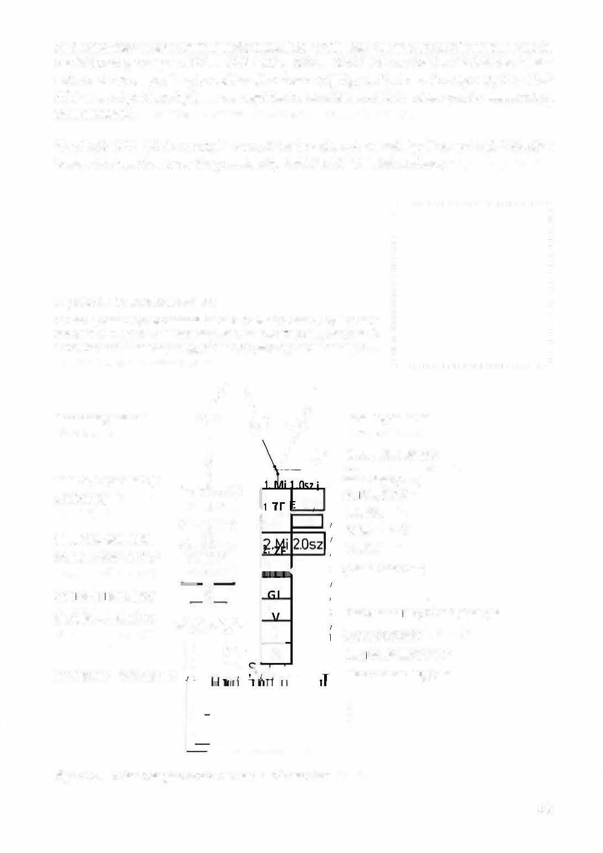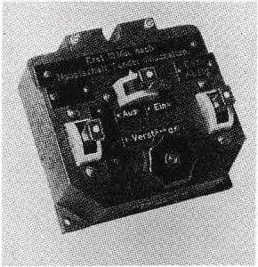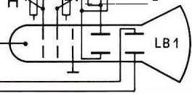

Figure 6 .1 1 Block diagram of the "Ho hentwiel" radar unit

55

and the experience gained with it. Several thousand units \t\/ere built of the FuG 200, which was not only used as an aircraft radio but also as a maritime radio on almost all ships, including S-, T- and U-boats (FuM0 61 to 65), as \t\/ell as in the ground panorama unit Jagdwagen. A further development, Hohentwiel 2, was continuously tunable from 525 to 575 MHz and had a close range resolution of 1 50 m. The transmitter and receiver used the same frequency. Transmitter and receiver used the same antennas via a simu lt switch.
The scientific staff at C. Lorenz AG in the field of radio measurement technology included: Dr. Heinrich Bosse, Dr. Helmut Carl, Dr. Karl Christ, Dr. Felix Gerth, Dr. Erich Gosse! Dr Kurt Haupt, Dr Felix Herriger, Dipl .-Ing. Edmund Löpp, Dr Maximilian Messner, Dr Gotthard Müller, Dipl.-Ing. Dieter Rappold, Dr Walter Schnabel. The author owes special thanks to Dr Müller for checking the technical data of the FuG 200.

Figure 6.12 FuG 200 transmitter module
On the left and right the two transmitter tubes R D 12 Tf, between them the line circuit, at its lower end the short-circuit slider for setting the frequency. At the upper end was the coupling loop with which the HF energy was transmitted to the antenna tuner.

11 hea11te1111

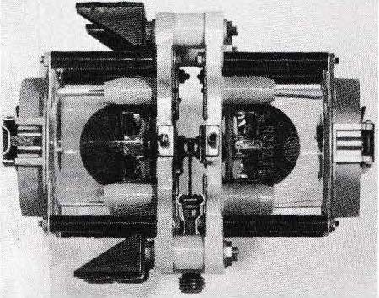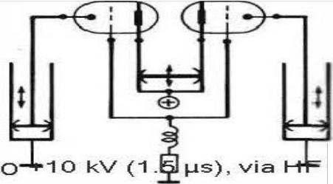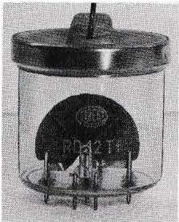i:""--:>
C
550 MH z

R D 12 Tf
Fitting device

choke I wa

Figure 6.13 RD12Tf transmitter tube. .6.
Frequency range up to 700 MHz, HF pulse power up to 25 kW, anode voltage up to 18 kV, diameter 7 cm . Beginning and end of the anode surface are led out with socket pins, so that the anode could be organically inserted into the circuit (cf. Fig. 6. 12). The RD 1 2Tf
the most powerful tube for this high frequency range.

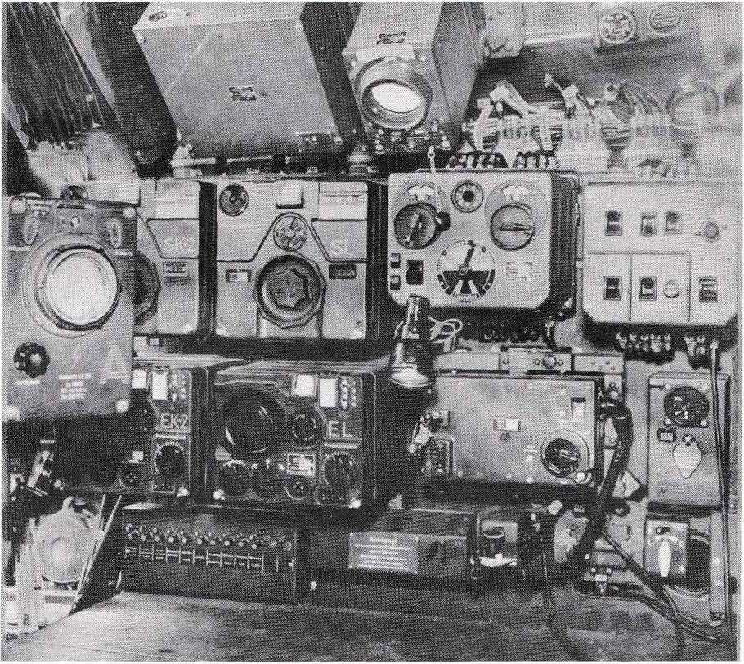

Figure 6. 14 Radio system in a four-engine long-range reconnaissance aircraft (Ju 290, Figure 5.8). Top : Receiver and sighting device of the FuG 216 "Neptun" backward warning device.
Middle row: Visual display unit of the search unit FuG 200 "Hohentwiel", next to it from the FuG10: short-wave transmitter SK 2, long-wave transmitter S L, remote control unit and radio control box.
Bottom row: From FuG 10 the shortwave receiver EK 2 and the longwave receiver EL, furthermore landing receiver EBI 3 and display unit AFN 2.
At the bottom: automatic safety devices, morse key and direction finding antenna control switch ( LI R). The radios located below the radio operator's work table are shown in Figure 3.6.

A similar aircraft to the Ju 290 was the Focke-Wulf Condor Fw 200 C pictured on the cover of the book. lts characteristic features: first flight as a long-haul aircraft for civilian air traffic in July 1 937. A year later it became famous for the Berlin - New York and Berlin - Tokyo flights of Deutsche Luftha nsa. Used by the Luftwaffe from 1 940. Length 23.50 m, wingspan 30.90 m. Four air-cooled
9-cylinder radial engines from BMW, 750 kilowatts ( 1000 hp) each. Range approx. 6000 km. The radio equipment was similar to that of the Ju 290 (Fig. 3 .6, 6. 7 and 6. 14).

57

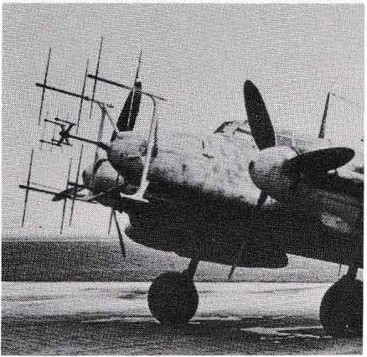The radar unit ( radio measuring device)
,, Lichtenstein"

Lichtenstein SN2 (FuG 220) was the best-knovvn radio measuring device used by the German night fighters to ward off Allied bomber incursions. lt was an active radar device in which the radio operator could see on two screens whether and at what distance (up to about 8 km) other aircraft vvere flying, in which direction they vvere and what their altitude was in relation to his ovvn aircraft's longitudinal axis (Figure 7.3).

Figure 7. 1
Night fighter Messerschmitt Me 1 1 0 with antenna of the FuG 220 " Lichtenstein SN 2" search device
In front the four dipoles, 1 15 cm long, behind each a reflector. The sm all antenna of the same design in the middle belonged to the FuG 202 or FuG 212 search unit that was used in the beginning.

The FuG220 operated in the 91 MHz (3.3 m) frequency range, i.e. in today's VHF broadcasting range. lts pulse duration was 1 µs, the pulse frequency was 9 00 Hz. The transmitter was operated with anode keying: it received anode voltage pulses of 2 kV and 1 µs du ration. With 1:\1'\0 LD 15 tubes in back-to-back connection, it delivered an HF pulse povver of 1.5 kW. The anode voltage pulses for the transmitter were generated by a probe that was connected to the transmitter.
- tubes and consisted of an oscillator, pulse shaper and power amplifier.

58

The receiver was a Superhet with IF = 4.4 MHz and ban dwidth 1. 1 MHz. With a remote control unit (rotary encoder, like the FuG 1 0) the radio operator could fine­ tune it from 90 to 92 MHz.

The display unit (Fig. 7. 2) was equipped with two LB 8 oscilloscope tubes for side and height display, as we/1 as 5 additional tubes. lt was controlled with the output voltage of the receiver (lag generation). With a remote-controlled switch, the radio operator could switch the antennas and the display unit to either side or height display (initially with a Bowden cable, then electrica/ly by pressing a button).

Figu re 7.2
Visual display unit ofthe F uG 220 (width 21 cm).
On the left the picture tu be for the side display, on the right for the height display. 1 n the centre the ra nge selector "4 km/1 0 km"; to the right of it the sca I e I e ngth setting slot, to the left the setting slot for calibrating the zero point; on the outside the two rotary knobs for brightness. 1 n the bottom row from left to right: rotary knob "Close-up resolution" for minimising the zero point; rotary switch "Alternative frequency" for changing the 900 Hz pulse frequency in case of interference from other FuG 220s; rotary knob for receiver sensitivity; setting slot for sharpness.

Figure 7.3
Screen display of the FuG 220.
Left side, right height display. The electron bea m writes hel I sca I ed poi nts du ring the time calibration: in the 1 0 -k m2range every 2 km, in the 4-km- range every
1km.

N 1 2 E

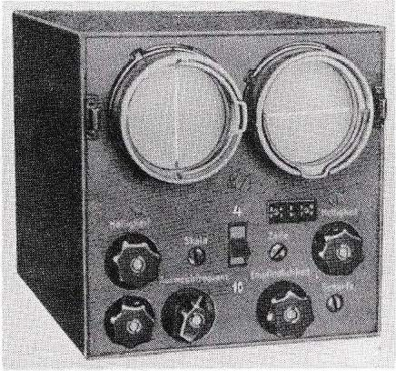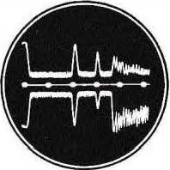Nul I jags (own jags). 2 Target lin ks N
ahead and higher, distance 6 km. 1 Target
exactly ahead, at the same altitude, distance 4 km. Earth's surface in 7 km.
♦

The FuG 220 had four current-coupled dipoles of 1 1 5 cm length, tuned with coils to N2, as we/1 as four reflectors. The poles can be interconnected with the help of reversals in such a way that the en tire antenna "squints" left ahead or right ahead, i.e. two directional diagrams are created. These

59

Switching was done by a motor switch at 25 Hz intervals, so that the receiver alternately received the antenna voltage of the left or the right directional diagram, resulting in a comparative display as in Fig. 6.5. The side display was on the left picture tube.

Page Height

1GJ> 1GJ> 1GJ>
Figure 7.4
Different interconnection of the FuG22 0 dipoles
for side and height display

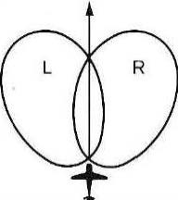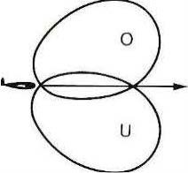
When the radio operator switched the four antennas together with the remotely operated antenna switch (hand switch) in the other order according to figure 7.4, directional diagrams were produced up-fotward and down-fotward (figure 7.5). These two directional diagrams, alternately switched on with the motor switch, resulted in the comparative directional diagram for "altitude". To the display
the right-hand picture tube now served. The bearing accuracy for height and side was
± 20

Figure 7.5 Antenna diagrams for side and height.

The same antenna system also worked as a transmitting antenna in simultaneous operation: When transmitting, the receiver input was short-circuited with a nullode (gas discharge tube) and thus protected from the high transmitter output power. A line circuit ensu red that the transmitter and antennas were not affected by this short­ circuit.
The predecessors of the FuG 220 "Lichtenstein SN 2" were the FuG 202 "Lichtenstein BC" and its next version FuG 212 "Lichtenstein C". The FuG
202 was built in 1942/43, followed by the FuG 212 in 1943. These radio measuring devices had three indicator tubes, one each for distance, lateral and altitude indication; operating frequency was 490 MHz (61 cm), pulse power 1.5 kW, range approx. 200 m.
up to 4 km.
Until the beginning of 1944, the FuG 202 or 212 was still used in night fighters because of its good close range resolution of 200 m, even after the FuG 220 had been installed.

60

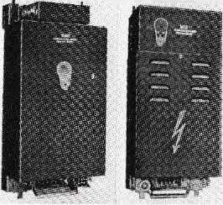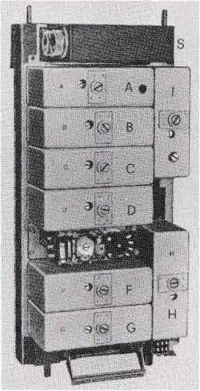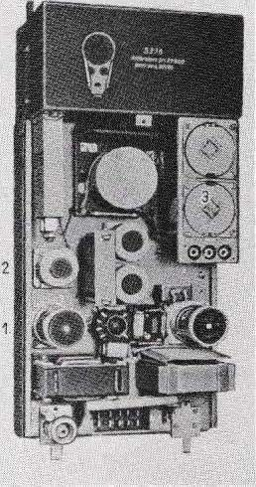because the FuG 220's close-up resolution initially only set in at about 800 m, which was not enough to detect the enemy in the sky on dark nights.
At the beginning of 1 944, the close range resolution of the FuG 220 vVas improved to approx. 300 m, so that the additional operation of the older devices was no longer necessary.

Bli d7.6
Receiver and transm itter of the FuG220 (width 19 cm each).

Figure 7.7
Left: Receiver of the FuG220.
S Simultaneous device (separater) for the common transmit-receive antenna. A and B H F amplifier; C mixing stage;
1 oscillator; D E F G IF amplifier; H NF am plifier with2X LV1; A to Gundl with pentodes RV 12 P 2000, in Gauch Gleichr. LG 1.
Right: FuG220 transmitter and keypad. Above, closed, the HF transmitter with 2 X LD15. Below, opened, the keypad. 1 Oscillator with LV 1, next to it pulse shaper with RV12 P 2000 and LV1; 2
amplifier stu dies with LD 2 and 2 X LD2; 3 power amplifier with 2 X LV13.

The defensive successes of the night fighters in 1 943 and 1 944 were essentially due to the help of the Lichtenstein and the Naxos devices mentioned in the next chapter. Although all radio measuring devices that worked with a vVavelength of approx. 60 cm (Würzburg, FuG 202, 212) had been interfered with by the enemy since July 1 943 by dropped staniol strips of half wavelength (chaff, Win dow) , the FuG 220 could still work perfectly until July 1 944 because of its longer wavelength (3.3 m). Then, however, also

61

longer staniol strips were used, which impaired the display of the FuG 220. As a remedy, the S N2 devices were converted to alternative frequencies, so-called stray waves, which lay in the wide range of around 60 to 120 MHz. From October 1944 onwards, however, all stray waves were interfered with; despite this, it was often still possible for experienced night fighters to detect and approach the bomber stream within the many window spikes.
The Lichtenstein and Naxos devices \t\lere developed and built at Telefunken. The scientific statt in the field of radio measurement included: Dr. Leo Brandt, Dr.
H. Bruckmann, Prof. Kurt Fränz, Dr. Waldemar lhlberg, Dipl.-Phys. Ernst Kettel, Dr. Knoll, Dr. Kotovvski, Dr. Fritz Kruse, Obering. Maas, Obering. Herbert Muth, Dipl.-Ing. Theodor Pederzani, Dr Horst Rothe, Dr Karl Rottgardt, Prof. Wilhelm Runge, Dr Steimel, Dipl.-Ing. Wilhelm Stepp, Dr Günther Ulbricht, Dr Rudolf
Urtel.
w

91MHz.

s

-280 V
DI +Ua
'MI
lµs

J 100

Figure 7.8 H F- transm itter of the FuG220

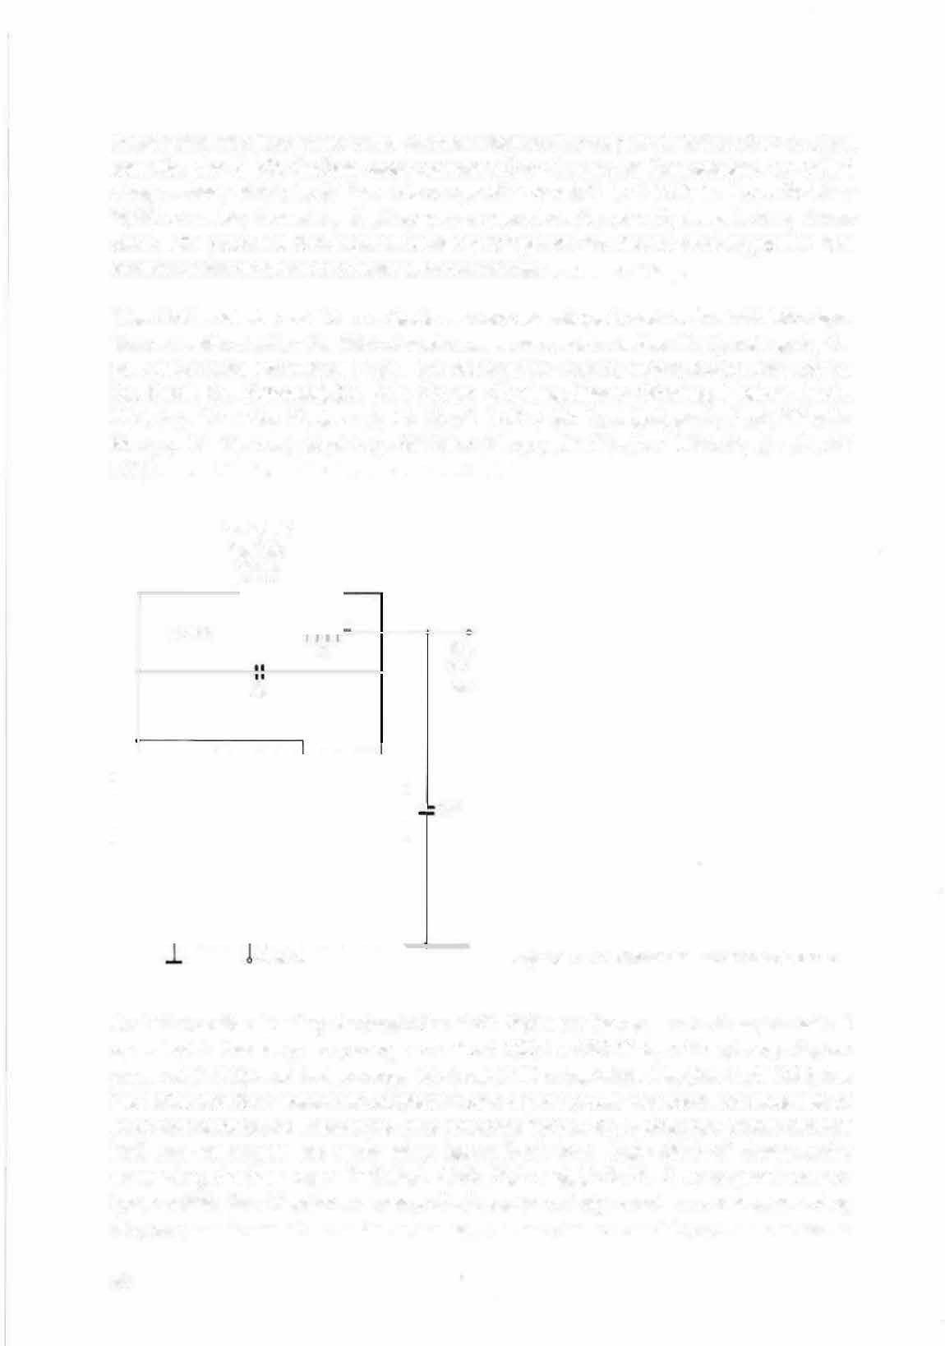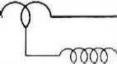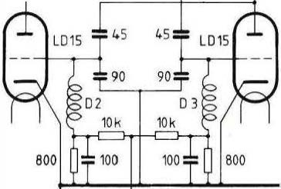

A similar active homing device to the FuG 220 was the FuG 2 18 "Neptune". lt operated in the frequency range of about 160 to 190 MHz, with a transmission power of 2 kW, and had a range of about 200 m to 5 km. Like the FuG 220, the FuG 218 had four antennas consisting of a dipole and a reflector, but because of the higher operating frequency they only had to be 70-80 cm long. Some aircraft had two antennas on each wing instead of four. Only 200 of these radio measuring devices \t\lere installed. FuG 216 and FuG 21 7 were predecessor types with in the Neptune series, which \t\lere mainly used as reverse warning devices.

62

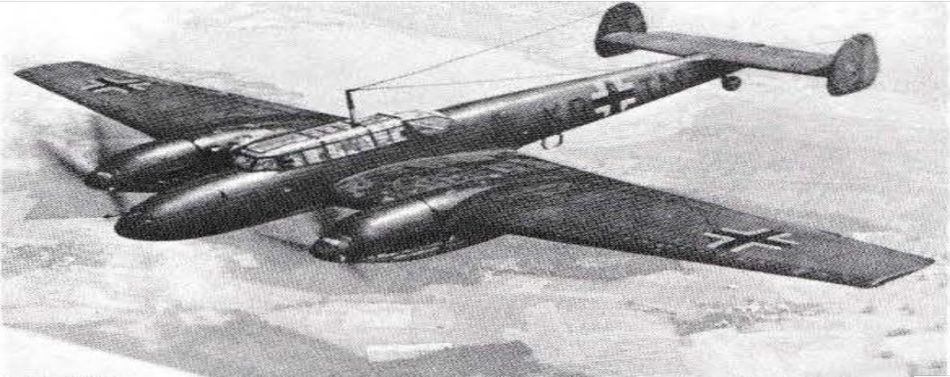were used (Figure 6.14). Neptu ne devices had been under development since
, 1 940 by the FFO Flight Research Institute (H. Heine, Dr. P. Maurer) in
cooperation with Siemens (H. Brandau, H. Hagenaus).

Figure 7.9
Messerschmitt Me 110.
Maiden flight May 1936. Crew of 2 - 3, wingspan 16.25 m,
length 12.10 and 12.60 m respectively. Two 1 2-cylinder Daimler-Benz engines, each 11 00 kilowatts (approx. 1500 hp). About 6000 of this aircraft, which was particularly successful in its use as a night fighter, were built.
The on-board radios FuG 10 P, FuG 16 Z or ZY were located below the antenna mast at the position of the on-board radio. The landing system FuB 1 2 and the identification device FuG 25a were located in the fuselage approximately above the trailing edge of the wing. Two T-antennas for FuG 10 and FuG 16 were stretched from the mast to the vertical stabilisers. On the underside of the fuselage, below the crossbeam, was the rod antenna for FuG 25a and the antenna for the landing system. The transmitter, receiver and antennas of the FuG 101 a were located on the underside of one wing. The fixed homing frame of the FuG 16 was located on the underside of the fuselage in front of the beam cross, the rotating direction fin antenna of the FuG 10 P on the upper side of the fuselage.

63

Bild 7.1O Junkers Ju 88. Nachtjagdausführung
'\f
Spa„oMnowtoeriteen2v2o,n1o mUuil\�eärsng, Jee 14o m, bei anderen Baureihen bi$ zu 1ß,2₉.m "'ei 12-2yun­

der
J hlO O Kilowatt (ca. 1800 PS). Re,chwe,te DIS 5uUo km. Besat­

zre41cniP11en3-.§t-luMgzaenung.typErswtufrf_qgaenDnl:>eomoober 1936. Von diesem vielseitigen und besonders erfolg­

Stück gebaut.
Zur

Bordfunkanlage der Ju 88 gehörten: FuG _{10,} EZ 6Ji�ffl
z,iii·

FuBI 2, FuG 25a,

FFuuGG 120217a. Buerfebrneai lar;rehtrnjäg�erdeds'fatfdrdesae1�äataargteuraiel as
z sowie eventuell H O .Hohentwiel" ein-

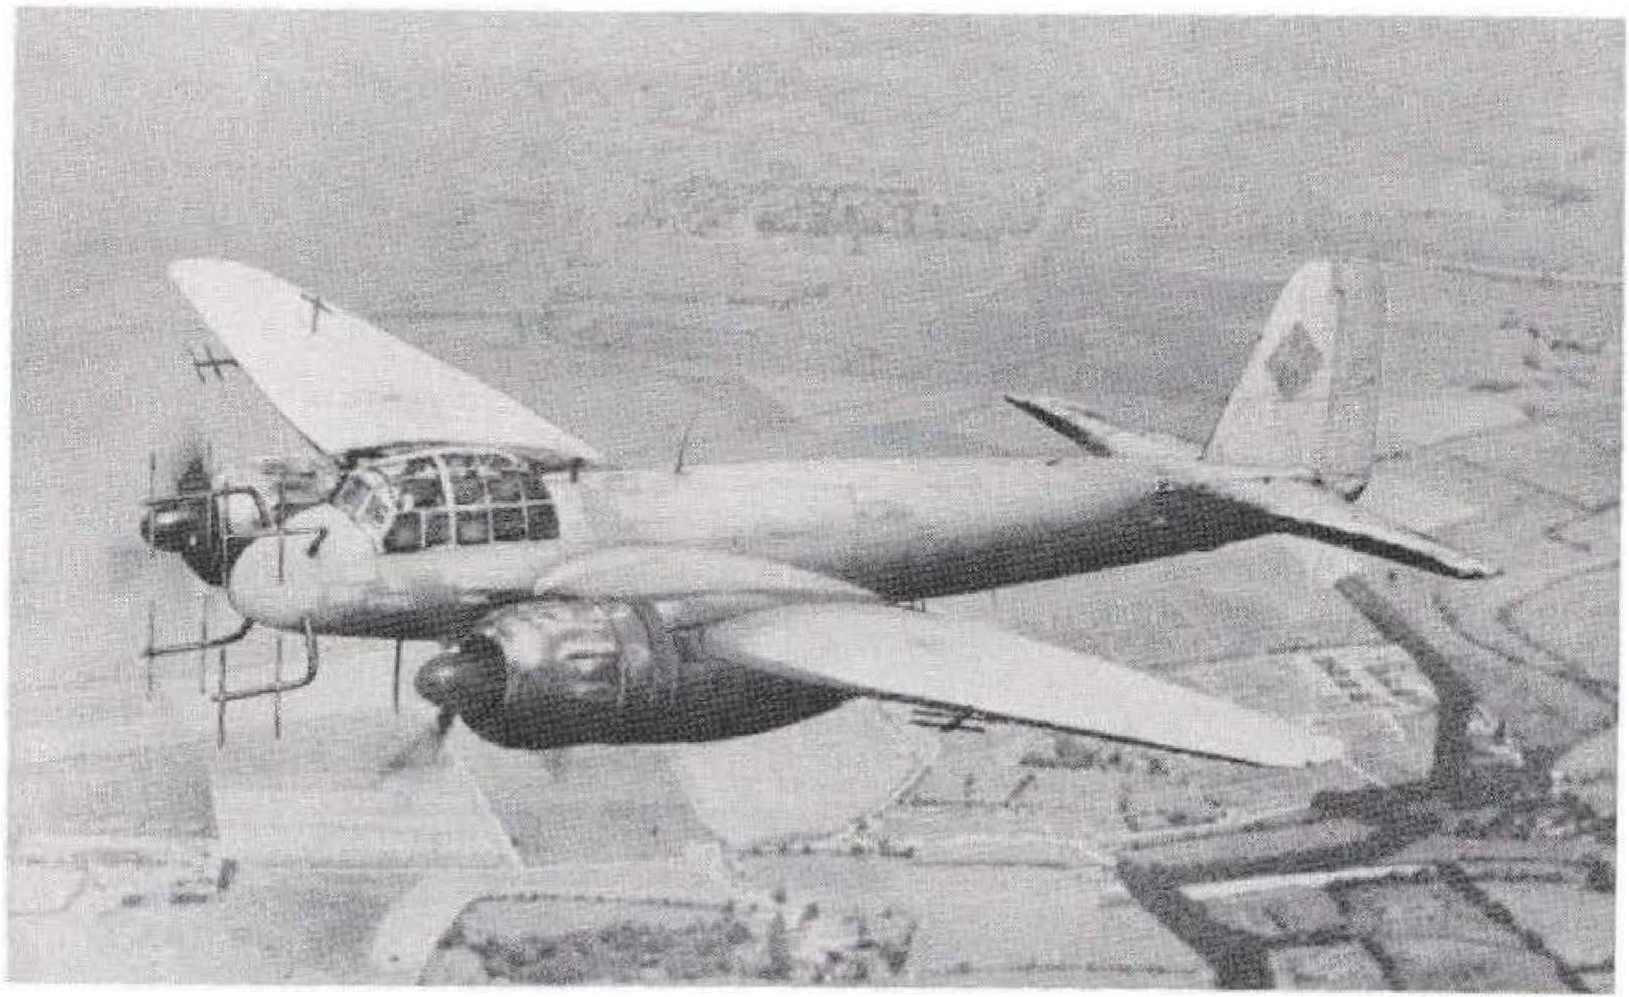gebaut. Das FuG10 war am hinteren Ende der Kabine auf der in Bild 2.1 geze;gten Geräte­
tafel angeordnet. Dort befanden sich am Platz des Bordfunkers auch die Radar-Sichtgeräte. Die anderen Funkgeräte waren im Rumpf untergebracht. etwa zwischen Tragftächenhinter­ kante und Austritt der zur Mitte des Seitenleitwerks gespannten FuG16-Drahtantenne. Die FuG1 0-Antenne verlief vom Antennenmast zur Oberkante des Seitenleitwer1cs. Die drehba1'8 Peilantenne war an der Rumpfoberseite angeordnet, in Gegend der Tragflächenhinterkante. A�ruii.cmetl"�l"ah.eimeSnlneeflaeds�rU&,uqipfunterseite befand sich die Stabantenne des FuG 25a sowie die
steheri�e Zielflugrahmen �e� Fl_JG 16 Z (bzw. ZV) angebracht. An der Unterseite der linken
i
10. Weiter hinten waren die Antenne der Landeanlage und der fest­
uß gij�"

ein „ ZU S8 4 Dipole und 4 Reflektoren). Die rotierende Antenne des FuG 350 Z
de
z
i öer
�8 tst ate .n1rscngewe1�•Amenne
TragflacheAnfana
we e ubJjU1cti SenQ,Sr, 1iJ!IRfän.9.er:!tl�l\nlenfl!uesn �r-uu" tMhenmessers
;
h
1.1.0 ,Jichten-
„Nax� befand sich an der Oqerse,te des Rumpfes. An der hier abgebildeten Ju 88 sind auch die Antennen des nFlensburg" zu erkennen: An der Vorderkante der Trag­
FUG 227
flächen die Antennen für Links-voraus und Rechts-voraus, an der Oberseite der rechten Trag­ fläche für Oben (an der Unterseite für Unten).

..
64

H2S radar, Naxos and Berlin device

In February 1943, a new type of on-board radio was found in an English aircraft that had crashed near Rotterdam. The investigation revealed that it was an omnidirectional radar with a panoramic view of the area being flown over. lt operated in the centimetre wave range at 3.3 gigahertz (9 cm) and, at this small wavelength, made do with a rotating mini-antenna that could easily be accommodated in the aircraft. The device scanned the area being flown over with its radar pulses, and the reflected pulses depicted coastlines, rivers, lakes and cities on the screen of the electron beam tube as on a map. This radar device was thus a new means of navigation that helped the Allied aircraft to find the city to be bombed even when the cloud cover was closed or at night.

Figure 8.1 Naxos antenna.
Above, the two stem radiators from Tolitul, including drive motor with two-phase generator.

II

Didcktrisdie ArHeime

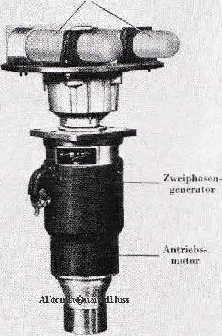

1 1/
I
II 11
,.
,, 1W l
II
11
✓//
Figure 8.2 Effective range of the 65
)S.

The most important task on the German side was to prevent the tactical use of this panorama radar "H2S", which was called the "Rotterdam device" in Germany. After several immediate solutions, Telefunken created an on-board radio for day and night fighters that could receive the radar radiation and indicate the direction to the transmitting aircraft on a picture tube. This FuG 350 Z "Naxos" radio was a centimetre wave receiver with a downstream amplifier and sight. Its antenna produced the directional effect with two approximately 2 0 cm long plastic rods (dielectric stalk radiators, Figure 8.1). This directional antenna rotated in the horizontal plane by motor drive at about 15 revolutions per second, scanning the entire 360 · environment
(Figure 8.2). At the same time, generator windings mo°unted on the motor
generated two alternating voltages phase-shifted by 90 , which - applied to \
the pairs of plates of the oscilloscope tube - caused a circular deflection of the electron beam. The beam rotated synchronously with the rotating antenna. At
the moment the antenna picked up radar radiation, the electron beam was 1
brightly scanned and the luminous spot on the screen indicated the direction
from which the radiation came (Figure 8.3) . With this directional information, the fighter was able to homing in on the transmitti.ng scout aircraft and the bomber group in its vicinity. The range of the Naxos device was up to 100 km.

\
Figure 8.3 Naxos umbrella images
Left picture: Opponents ahead on the right.
Right picture: Opponents in the immediate vicinity.

The Naxos antenna was installed on the top of the aircraft, protected by a plastic cover; in the Me 109, for example, directly behind the antenna mast. The receiver's crystal diode, which functioned as a detector, was located dose to the Naxos antenna and coupled to it via a capacitive rotary coupling. A high-pass filter ensured that only the relevant frequencies of more than 2.5 GHz were received (reception range 2.5 - 3.8 GHz). The sight housing contained an amplifier with 4 X E F 14, the picture tube DG 7-2, as weil as the power supply unit with a rectifier tube RFG 5. First, single-seat fighters (Fw 190, Me 109) were equipped with the FuG 350 Z, then also about a thousand night fighters. The navy also used over a thousand Naxos devices, especially on submarines as warning receivers against attacking aircraft with H2S radar. When it became clear in the spring of 194-4 that the enemy also bad a panorama radar (H2X or Meddo), the Naxos was used.
66

l

with 10 G Hz (3 cm); as a countermeasu re, a special version of the Naxos was built that covered this freq uency range.

As passive rad io measuring devices, the Naxos devices had the g reat advantage that they could not be disturbed by the staniol strips (chaff, window) d ropped by the enemy.

Figure 8.4 Naxos display unit (width 12 cm)
Picture tube with circular deflection,
adjustment knobs for brightness and
sen sitivity,
Near/far switch. (The first versions did not have a near/far switch).

f♦1 1♦J Ci rcttb..--d�---1-c� -,
'
2xu♦•f⁼9o·
OG7-2 500k 200k

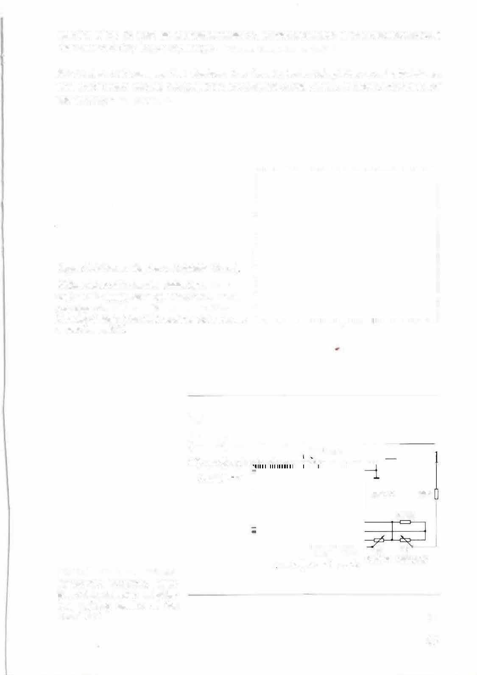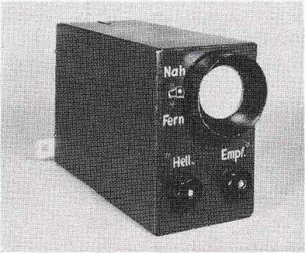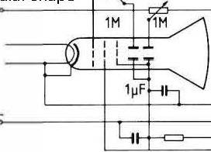

Figure 8.5 Antenna, high­ pass filter, detector, amplifier and sighting device of the FuG 350 Z.
1M 1M
O :L� F I SOOk Schärfe Helligkeit

67

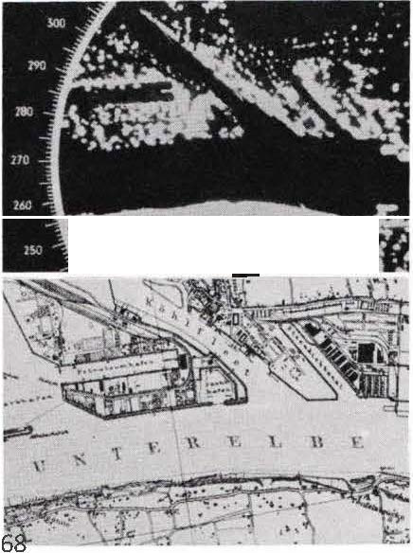Another passive search device, but for longer waves around 200 MHz, vvas the FuG
227 "Flensburg", of which, however, only about 500 were built from mid-1 944. lt was used as a homing device on jammers and on the beam of the British reverse radar Monica, which vvas supposed to protect the bombers from the German night fighters.

Of course, Germany also did its utmost to reproduce the captured H2S and H2X radars. The work on the centimetre viave range (which was not considered "important for the war") was carried out with great energy in 1 943/44, and the panorama device "Berlin -A" (F u G 224) and the night hunting device "serlin-N" (FuG 240) were developed, although they could not be used until March 1945. A great deal of further development work in the centimetre wave range vvas carried out in the laboratories of industr al companies and institutes, but it did not lead to any operational series of devices and is therefore no longer the subject of this publication.

.... • • f ..• • -,
.
. .
0V

BI i d 8.6 Picture tube of a radar with panoramic view of the illuminated area. Below, for comparison, the corresponding map.
Water surlaces reflect the radiaticn away (do not reflect) , the screen remains dark in these places. Buildings and similar prominent objects reflect strongly and appear b r i g h t o n lt e screen.

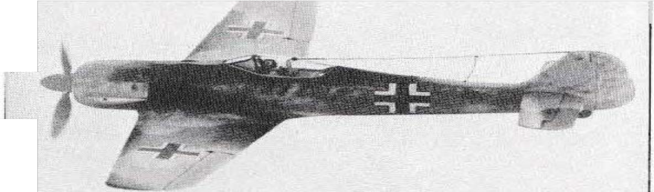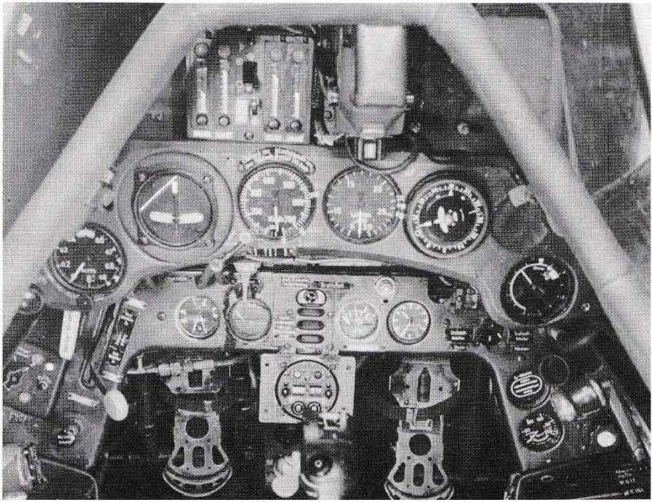BI i d 8.7 Fighter aircraft Focke- Wulf Fw 1 90.
First flight June 1939 in Bremen, wingspan 10.50 m, length 8.85 m, range approx. 900 km. Equipped with an air­ cooled 14-cylinder twin-star engine by BMW, 1 250 kW (1 700 hp).
20,000 of the Fw190 were prod u ced, a nd after 1 945 it continued to be built in France as the N 900.
The FuG 16 ZY aircraft radio was located in the fuselage behind the pi I o t 's seat, followed by the FuG 25a identification device and the FuG 16 ZY homing device. The radios were accessible through a m anhole in the side wall of the fuselage, to the left of the crossbeam. The transmitter of the FuG 16 ZY worked with a T-antenna stretched from the canopy to the rudder.
The receiver had a rod antenna mounted on the underside of the left wing root. Below the crossbeam on the underside of the fuselage was the homing frame of the FuG 16 ZY.
tenne of the FuG 25a. The possibly existing Naxos antenna had its place under a Plastic hewing on the upper side of the fuselage. - Cockpit of an Fw 190 (A4) :

69

Figure 8.8
Cockpit of a 31
Fighter aircraft
Focke-\Nulf Fw 190 (AS)
4
5 35
6 36
7 37
8 38
9 40
10 41
11
42
12
13
14
15
16
17
18

20

28 �f-#:'!Fl-il'/f""'
30 ----m'-i---1

n�---".::l'f"'
�50
!;'IIIIIIII 5 1
tä\.l�lrt!! 52
53
��M�- 59
k11111r 60
\�llllUIU,
111---- 61

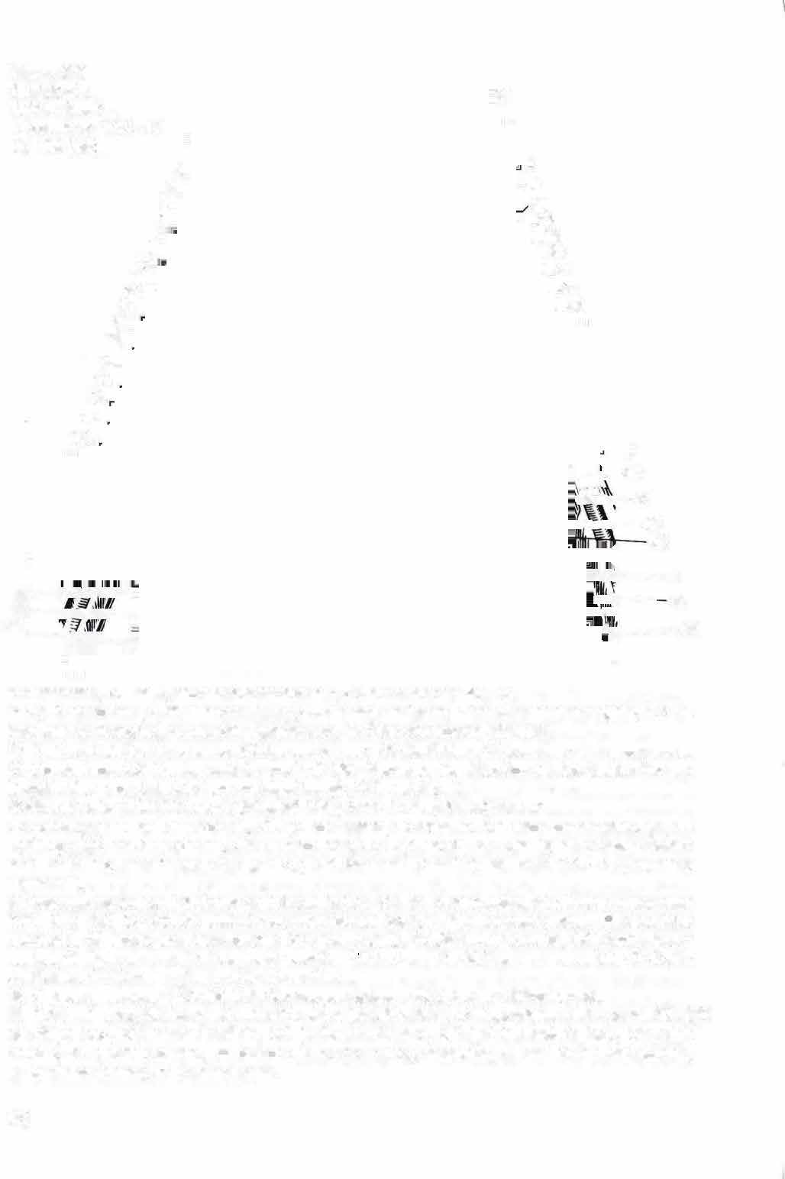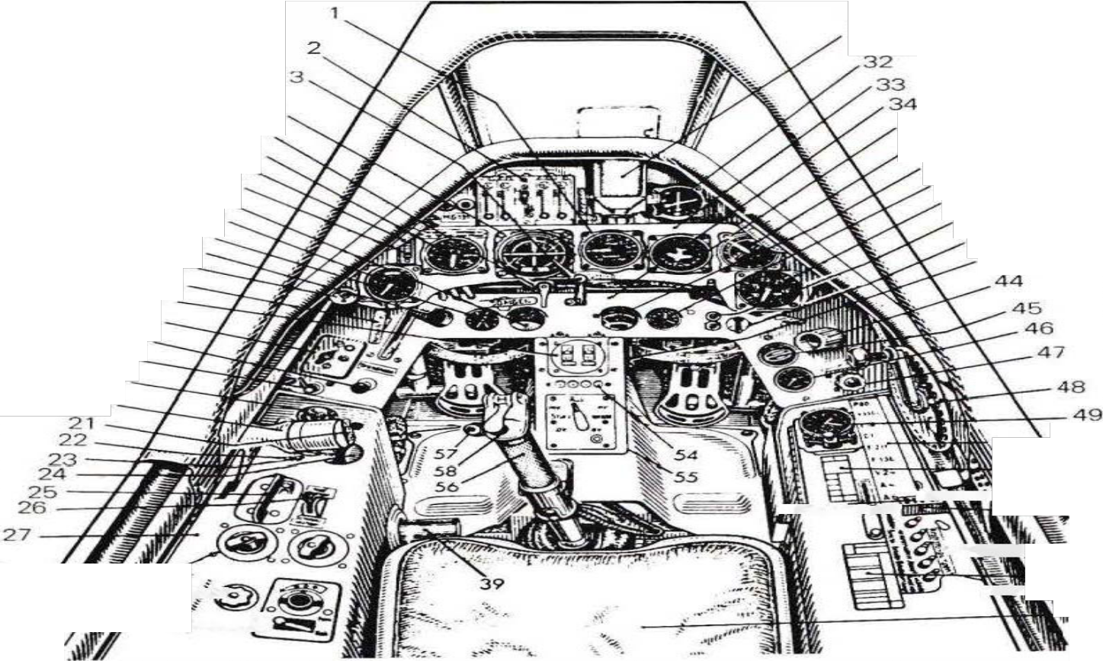
1 Variometer, 2 Switch , counter and control box, 3 Hand crank for fan flap,
4 Artificial horizon, 5 Windscreen rinse, 6 Airspeed indicator, 7 Instrument panel lights, 8 Pitot tube heater indicator, 9 Lubricant tem perature, 10 Fine and coarse altimeter,
11 Fuel and lubricant pressure, 12 Fire cock lever, 13 Ventilation, 14 Landing gear em ergency, 15 Control box, 16 Control unit for the FuG 25a friend/foe identification device (switch for key identification 1 or 2, test button and s i gn al 1am p), 17 Brush lift-off,
18 Shut-off valve 1, 19 Unit board lighting, 20 Lifting � 21 Propeller adjustment
22 Landing gear and flap control, 23 1 gnition switch, 24 Position indicator for elevator trim, 25 Landing gear and flap control, 26 Elevator trim, 27 Left bench, 28 Side by side: Mode switch and frequency switch for FuG 16 ZY, 29 Receiver retuning for FuG 16 ZY (frequency alignment),
30 Volume control and far/near switch for FuG16 ZY, 31 Reflex sight, 32 Aiming instrument AF N 2 of FuG 16 ZY, 33 Main in stru ment p an el, 34 H I i f instrument pa nel, 35 Daughter compass, 36 Boost pressure gauge, 37 Fuel supply, 38 Airscrew control, 39 Throttle lever control, 40 Rev counter, 41 Fuel level warning (' Rate Lamp"), 42 Fuel gauge switch, 43 Cabin ventilation, 44 Flare gun holder, 45 02 monitor,
46 Oxygen pressure, 47 Quick drain for oxygen system, 48 Drive for sliding bonnet,
49 Onboard clock, 50 Automatie circuit breaker (on/off switch), 51 Operational data panel, 52 Light cartridge box, 53 starter switch, 54 jettison indicator, 55 ignition switch box, 56 stick handle, 57 ejection button, 58 button for outer wing weapons, 59 switch for fuel pumps, 60 deviation panel, 61 p I an e seat.

70

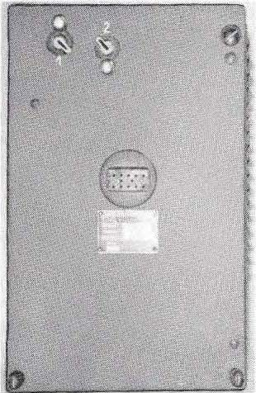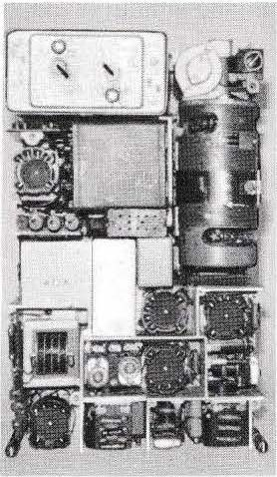The FuG 25a beacon

The FuG 25a "Erstling" radio, which was installed in almost all aircraft between 1942 and 1945, was an identification device that had the task of signalling to the ground stations that the aircraft was "their own" (friend/enemy distinction). The device worked according to the transponder principle: it was addressed by the ground station with request pulses and then transmitted a recognition signal on another frequency.

When the FuG 25a received interrogation pulses of frequency 1 25 MHz (± 1.8 MHz) from a ground radio meter, it automatkally transmitted back a set Morse code on 1 56 MH z. The pulse power of the transmitter was approx. 1 kW, range up to 200 km. Morse code was transmitted by a motorised cam switch controlled by a socket spanner with 10 break-out cams for dots and dashes. On the control unit, it was possible to switch to a second agreed Morse code. A control lamp lit up at the time of the Morse code and signalled to the crew that an interrogation was taking place.

Bi ld 9. 1
ldentification device FuG25a.
At the top left, the two slots and locking buttons for the l!iigkeys. A screw lock at the top right. 1 In the middle, the tester connection.

Figure 9.2 lnteriorview.
Top left: the key-operated switchgear, below: power supply unit and tester connection. Below, receiver and transmitter. At the top right, the motor converter (motor for the key switch undt�

71

Freya or Wassermann radios (125 MHz) with a "Gemse" identification receiver (156 MHz) vvorked as ground radio measuring stations, or Würzburg radios that had been retrofitted accordingly. The identification emitted by the Fu G 25a could also be evaluated by the ground station to locate the aircraft (position and distance). On this basis, the Erstling method for fighter guidance was developed in 1 942 at the Rechlin test site under the di rection of Tankred v. Hauteville, and in the follovving year the E GON method ( Erstling Gemse-Offensiv-Navi g:hi.

.......... 0

Fig. 9.3 Remote control unit of the FuG 25a with identification switch, test button and signal lamp. Drawing: Coding key.

<!ll MHar M ) Motor sScchhalültswseertk

Mi sctstufe�?eMrsHtäzr
le4ndller1 NF
erst� rker

Figure 9.4

FuG 25a

Transm tter {LSSOl Control stage

Birg n p a e 1
ldentification device FuG 25a.
Tube configuration : Transmitter LS 5 0,
control stage and Oscillator LD 1, other stages P 200 0.

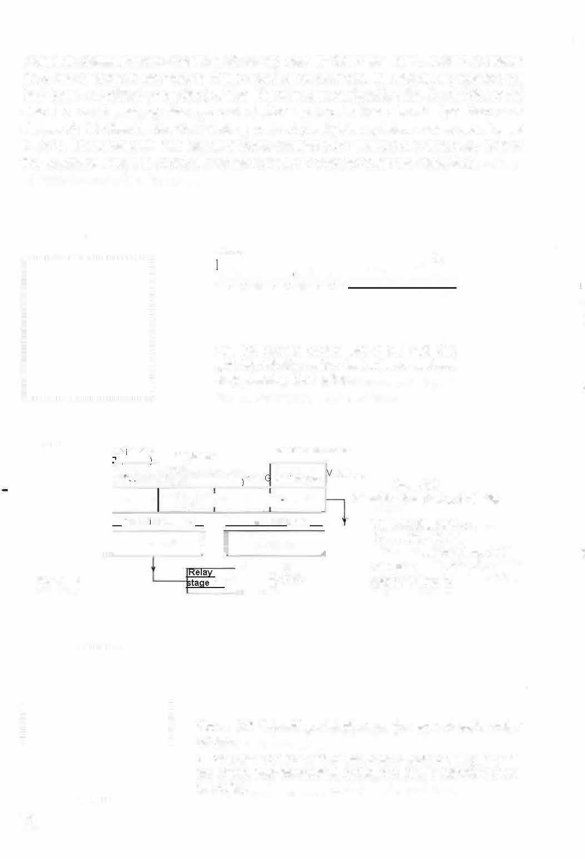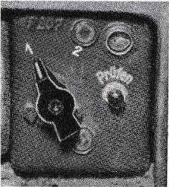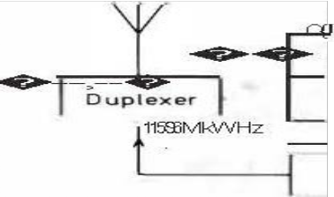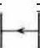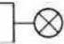

Figure 9.5 Friend/Foe detection on the ground radio meter screen.
E Own aircraft; the identification code K pulsed in rhythm with the Morse code transmitted by the FuG 25a. F Friendly aircraft (no code).

72

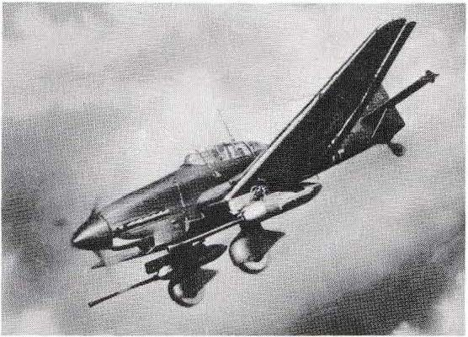The FuG 25a was built in }arge series by the Gema company. A further development by Lorenz (Dr. Kloepfer) was the FuG 226 "Neuling", which was able to answer several interrogators operating in the 1 1 0 - 125 MHz range practically at the same time.
The FuG 25 used in some aircraft from 1 940 to 1 942 had a similar type designation as the FuG 25a, but was an essentially different device: reception frequency 560 MHz, lower receiver sensitivity, transmission power only 1 W, external characteristic was the division into two device blocks: Transmitter-receiver and scanner.

BI i d 9.6 Junkers Ju 87, anti-tank version.
Crew 2 men, length 11,1 O to 11,
50 m, span
range 13.8 O to 15.20 m. 12- cylinder Jun kers engine, 100 0 kilowatts (13 00 hp). Range approx. 1 000 km. First flight at the end of 1935, approx. 6 000 built. The FuG16 Z (previously the FuGV 1 1) for radio
communication and homing in the cabin below the antenna mast.

73

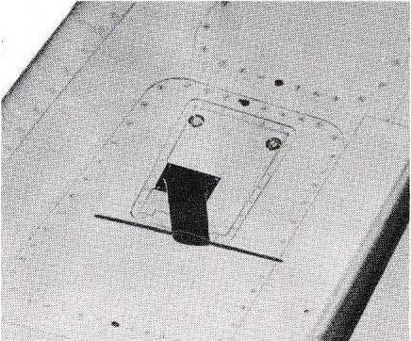The FuG 101 a radio altimeter

The altimeter FuG 101a was an on-board radio which determined the flight altitude according to the radar principle and displayed it with a pointer instrument (Fig. 4.5) in two measuring ranges: 1. range 0 - 150 m, 2. range 0 - 750 m. The altitude was measured by the radar.

Fig. 1 0.1 An antenna of the altimeter FuG 1 01 a
on the underside ofthe wing.

The FuG 101a worked on the principle of a frequency-modulated continuous wave radar with evaluation ofthe frequency difference: The transmitter, which was installed on the underside of the wing, radiated a frequency-modulated (swept) HF oscillation of 375 MHz ± 19 MHz to the ground with its dipole antenna. lts transmitting power was 1.5 W. A small part of this energy was reflected by the ground and reached the dipole antenna of the receiver, which was also located in the supporting surface. Since the transmission frequency was constantly changing between 356 and 394 MHz, two frequencies were reaching the receiver at any given moment:
At a certain point in time (ti ) the H F energy radiated to the earth has
z. e.g. a frequency of 370 MHz. The voltage reflected from the ground (37 0 MHz) reaches the receiver after a running time of a few microseconds, i.e. at time
h. At this moment (h ), however, the receiver also receives energy coming directly from the trans mitter. At this moment (h ), however, the receiver also picks up energy coming directly fro m the transmitter, whose frequency has changed between 370 MHz and, for example, 380 MHz. This fre-

74

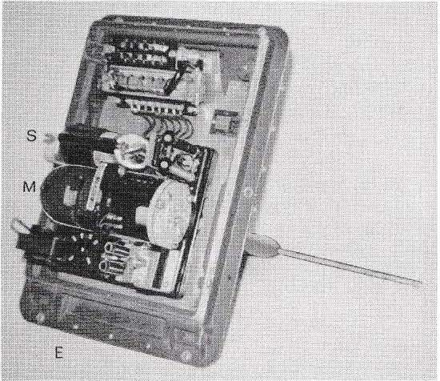The difference in frequency of 10 MHz is a measure of the time of flight and thus of the altitude; the higher the aircraft flies, the longer the time of flight of the radiation and the greater the difference between the two frequencies received. An evaluation circuit in the receiver converted the frequency difference into a direct current value, which was then displayed by the meter-calibrated pointer instrument (see Fig. 4.5).
To switch from the 150 m to the 750 m range, the frequency deviation of the transmitter was reduced from ± 19 MHz to ± 4 MHz by capacity reduction.

Picture 1 0.2
FuG1 01a altimeter transmitter, one dipole half visible.
The speed-controlled motor (4 000 rpm) drives the frequency-changing condenser (rotating butterfly condenser) .
M Engine
S Transmitting tube LD 2 E Tube RV 12 P 20 01
for calibration control

A calibration check of the altimeter was possible at any time, even during the flight: When pulling the control knob (figure 4.5), the pointer moved to a target mark; deviations could be eliminated by tuming the knob ( corre cture of the engine speed).
The receiver and transmitter of the FuG 101a were housed in similar cases and also bad similar looking antennas (Fig. 1 0. 1). The receiver was equipped with 6 x RV 12 P 2001 (push-pull audio and amplifier) and with an LV 5 in the evaluation circuit
The frequency-modulated altimeter FuG 101a was distinguished by its great accuracy: in the small measuring range, 0 and 3 metres could still be clearly distinguished. lt was therefore a good aid for bad weather or night landings. Compared to barometric altimeters, it also bad the advantage that it indicated the actual flight altitude above ground at any time and at any place and was not dependent on the air pressure at the location in question.
The FuG 101a altimeter was developed by Siemens (Sammer and Schönfeld). The Luftfahrtgerätewerk Ha kenfelde equipped more than 30,000 aircraft with it from 1942.

75

produced.
---
BI i d 1 0.3 Jet ai rcraft Messerschmitt Me 262.
Powered by two Jun kers jet engines, each with a thrust of 9000 new tons (formerly stated as 9 00 K raft - KI i ogramm or K I i opond). Wingspan 12.6 0 m, length 1
0.60 er 1 0.8 Om. Range approx. 1 000 km. The first flight with jet engine took place in J u ly 1 942.
approx. 15 00 copies were

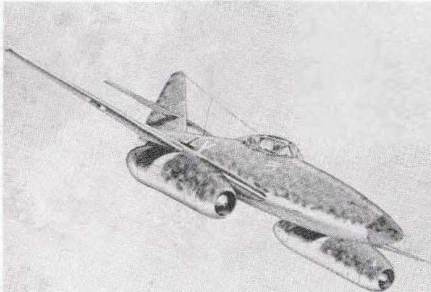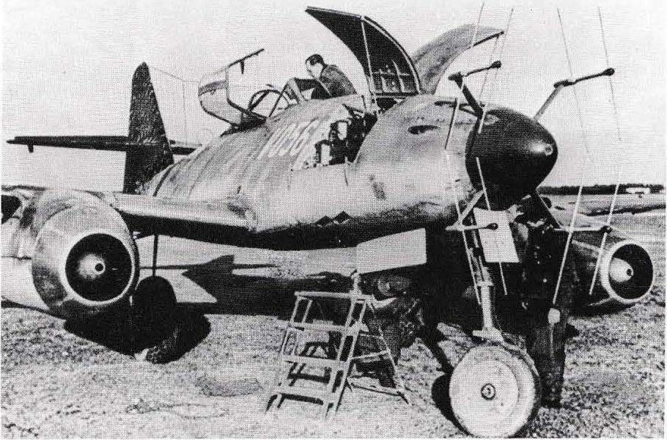

On-board radios installed in the fuselage behind the cabin were the FuG 16 Z Y and the landing receiver EBI 3, or the FuG24; also the identification device FuG25a. As a night fighter, the Me 262 was additionally equipped with the FuG 218 ( N eptune), whose "stag antler" antenna looked like that of the FuG220 ( Lichtenstein SN 2), but had somewhat smaller dimensions because of the shorter wavelength (cf. Fig. 7. 1 and 7. 1 0). The FuG35 0 Z ( Naxos) was also installed in some machines.

76

